**VIETNAM NATIONAL UNIVERSITY, HCM CITY**

**UNIVERSITY OF INFORMATION TECHNOLOGY**

**FACULTY OF INFORMATION SYSTEM**



**FINAL REPORT**

**CLASS: IS252.O21.HTCL**

**Predictions of Energy Consumption Levels of Buildings**

**Instructors: PhD. Cao Thị Nhạn**

**MSc. Vũ Minh Sang**

**Members of Group:**

|  |  |
| --- | --- |
| Thái Ngọc Dũng | 21521982 |
| Trần Hoàng Nhật | 21522420 |

**HO CHI MINH CITY, 2024**

TABLE OF CONTENTS

Chapter 1. INTRODUCTION 5

Chapter 2. DATASET 7

2.1. About Dataset 7

2.1.1. ASHRAE - Great Energy Predictor III 7

2.1.2. Historical Hourly Weather Data 2012-2017 7

2.2. Description of attributes 8

2.2.1. building_metadata.csv 8

2.2.2. train.csv 8

2.2.3. weather_train.csv 9

2.2.4. temperature.csv 10

2.3. Descriptive statistics 11

Chapter 3. DATA PREPROCESSING 12

3.1. Building Data Preprocessing 12

3.2. Weather Data Preprocessing 14

3.3. Train Data Preprocessing 33

3.4. Test Data Preprocessing 38

3.5. Combined Data Preprocessing 39

Chapter 4. DATA PREPROCESSING TECHNIQUES 40

4.1. Linear Interpolation 40

4.2. Variance Inflation Factor 42

Chapter 5. APPLIED ALGORITHMS 44

5.1. Decision tree 44

5.1.1. Definition 44

5.1.2. Algorithm 45

5.1.3. Reason for choice 46

5.2. LightGBM 47

5.2.1. Definition 47

5.2.2. Algorithm 47

5.2.3. Reason for choice 48

5.3. XGBoost 48

5.3.1. Definition 48

5.3.2. Algorithm 48

5.3.3. Reason for choice 49

5.4. Stacking 50

5.4.1. Definition 50

5.4.2. Algorithm 50

5.4.3. Reason for choice 51

Chapter 6. ACHIEVED RESULTS 52

6.1. Measurement 52

6.1.1. Mean Absolute Error (MAE) 52

6.1.2. Root Mean Squared Error (RMSE) 52

6.1.3. Root Mean Log Squared Error (RMLSE) 53

6.1.4. R-squared (Coefficient of Determination) 53

6.2. Reason for choice 54

6.3. Result 55

6.4. Comparison and Evaluation 55

Chapter 7. CONCLUSION 56

7.1. Advantages 56

7.2. Disadvantages 56

7.3. Development direction 56

Chapter 8. ORTHER 57

8.1. The task assignment table of team members 57

8.2. References 59

# INTRODUCTION

**Reason for Choosing the Topic:**

In the contemporary landscape of rapid urbanization and heightened environmental concerns, the efficient management of energy consumption in buildings is a critical issue. Buildings are significant consumers of energy, accounting for a substantial share of total energy usage globally. Accurate prediction of energy consumption levels in buildings is essential for developing strategies that enhance energy efficiency, reduce operational costs, and mitigate environmental impact.

**Current Situation and Challenges in the Market:**

The market currently faces several challenges related to energy consumption in buildings. These include:

* *Rising Energy Costs*: As energy prices continue to rise, building owners and managers are under increasing pressure to optimize energy use and reduce costs.
* *Environmental Impact*: Buildings contribute significantly to carbon emissions and other environmental pollutants. There is a growing need to minimize these impacts to meet sustainability goals and regulatory requirements.
* *Complexity of Energy Management*: The variability in energy consumption due to factors such as weather conditions, occupancy patterns, and building design adds complexity to energy management. Traditional methods often fall short in providing accurate and actionable insights.

**Project Approach:**

Given these challenges, our project aims to develop robust models for predicting the energy consumption levels of buildings. By utilizing advanced data analytics and machine learning techniques, we will analyze historical energy consumption data alongside various influencing factors. This approach will enable us to identify patterns and trends that can inform better energy management practices.

**Benefits of the Project:**

By conducting this project, we aim to address the current challenges in the market and provide several key benefits:

* *Enhanced Energy Efficiency*: Accurate predictions will enable building managers to implement more effective energy-saving measures, thereby improving overall efficiency.
* *Cost Reduction*: With better energy management, buildings can significantly reduce their energy costs, leading to substantial financial savings.
* *Environmental Sustainability*: By optimizing energy use and reducing waste, this project will contribute to lower carbon emissions and a smaller environmental footprint.
* *Informed Decision-Making*: The insights gained from predictive models will support data-driven decisions in building design, retrofitting, and operational strategies.

In summary, this study seeks to bridge the gap between raw energy consumption data and actionable insights. By predicting energy consumption levels accurately, we aim to create a sustainable future where energy resources are managed efficiently and responsibly, thereby addressing the pressing challenges faced by the market today.

# DATASET

## About Dataset

### ASHRAE - Great Energy Predictor III

1. *Dataset Provider:*

The data is sourced from ASHRAE. Founded in 1894, ASHRAE advances the arts and sciences of heating, ventilation, air conditioning, refrigeration, and related fields. With over 54,000 members in 132 countries, ASHRAE supports research, standards writing, publishing, and continuing education, shaping the built environment of tomorrow.

Source Dataset Link: <https://www.kaggle.com/competitions/ashrae-energy-prediction/overview>

1. *All files used in the project:*

building_metadata.csv: Data about the buildings supplied by the ASHRAE company, including 1449 rows and 6 columns.

train.csv: Data on energy consumption of buildings measured by meters, comprising 20,216,100 rows and 4 columns.

weather_train.csv: Weather data for each region, with 139,773 rows and 9 columns.

### Historical Hourly Weather Data 2012-2017

1. *Dataset Provider:*

The dataset was acquired using Weather API on the OpenWeatherMap website, and is available under the ODbL License.

Source Dataset Link: <https://www.kaggle.com/datasets/selfishgene/historical-hourly-weather-data?select=wind_direction.csv>

1. *All files used in the project:*

temperature.csv: Air temperature data for cities in the United States, Canada, and Israel, consisting of 45,253 rows and 36 columns.

## Description of attributes

### building_metadata.csv

|  |  |  |  |
| --- | --- | --- | --- |
| Order | Attribute | **Meaning** | Data Type |
|  | site_id | The ID code of the site | Nominal |
|  | building_id | The ID code of the building | Nominal |
|  | primary_use | The primary purpose of the building | Nominal |
|  | square_feet | The total area of all floors in the building, measured in square feet | Ratio-scaled |
|  | year_built | The year the building was completed and opened | Interval-scaled |
|  | floor_count | The number of floors in the building | Ratio-scaled |

### train.csv

|  |  |  |  |
| --- | --- | --- | --- |
| Order | Attribute | **Meaning** | Data Type |
|  | building_id | The ID code of the building | Nominal |
|  | meter | The type of energy meter  0: Electricity  1: Chilled Water  2: Steam  3: Hot Water | Nominal |
|  | timestamp | The recorded time | Interval-scaled |
|  | meter_reading | Indicates energy consumption in kWh | Ratio-scaled |

### weather_train.csv

|  |  |  |  |
| --- | --- | --- | --- |
| Order | Attribute | **Meaning** | Data Type |
|  | site_id | The ID code of the site | Nominal |
|  | air_temperature | Air temperature, measured in degrees Celsius | Interval-scaled |
|  | cloud_coverage | Amount of sky covered by cloud oktas: Clear sky (no clouds)   * 0 oktas: Clear sky (no clouds) * 1-8 oktas: Each okta represents 1/8 of the sky covered by clouds. For example, 1 okta means 1/8 of the sky is covered, 2 oktas means 2/8 (or 1/4), and so on. * 9 oktas: Indicates that the sky is completely obscured from view by other obstacles (e.g., fog, smoke) or sky conditions cannot be observed due to weather conditions. | Ordinal |
|  | dew_temperature | Dew point temperature, measured in degrees Celsius (Interval-scaled). It is the temperature at which air must be cooled to reach saturation (100% humidity), where water vapor in the air begins to condense into dew or droplets. | Interval-scaled |
|  | precip_depth_1_hr | Precipitation depth in one hour, measured in millimeters | Ratio-scaled |
|  | sea_level_pressure | Air pressure at sea level, measured in millibars or hectopascals (1mb=1hPa) | Ratio-scaled |
|  | wind_direction | Wind direction, measured in degrees from the north (0-360 degrees) | Interval-scaled |
|  | wind_speed | Wind speed, measured in meters per second | Ratio-scaled |

### temperature.csv

* There are columns representing 36 cities in the United States, Canada, and Israel.
* There are rows representing timestamps from October 1, 2012, to November 30, 2017, with each row separated by one hour.
* The values (intersecting rows and columns) are the measured air temperatures.

## Descriptive statistics

With category attributes:

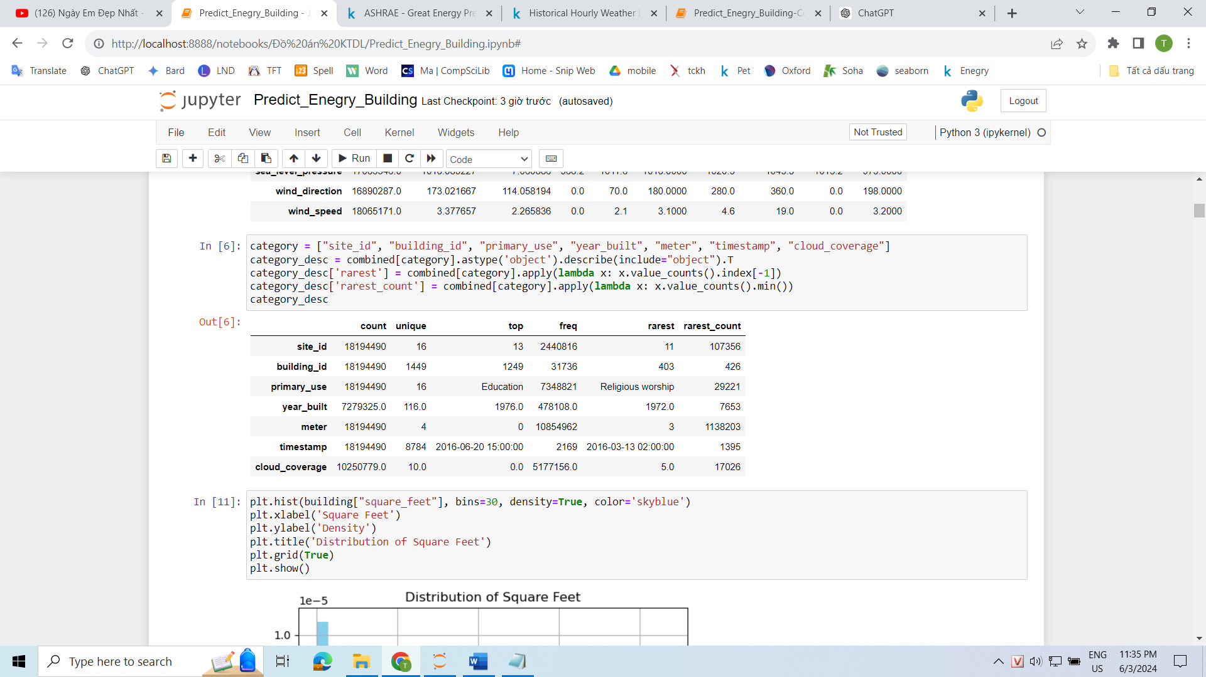

With numeric attributes:

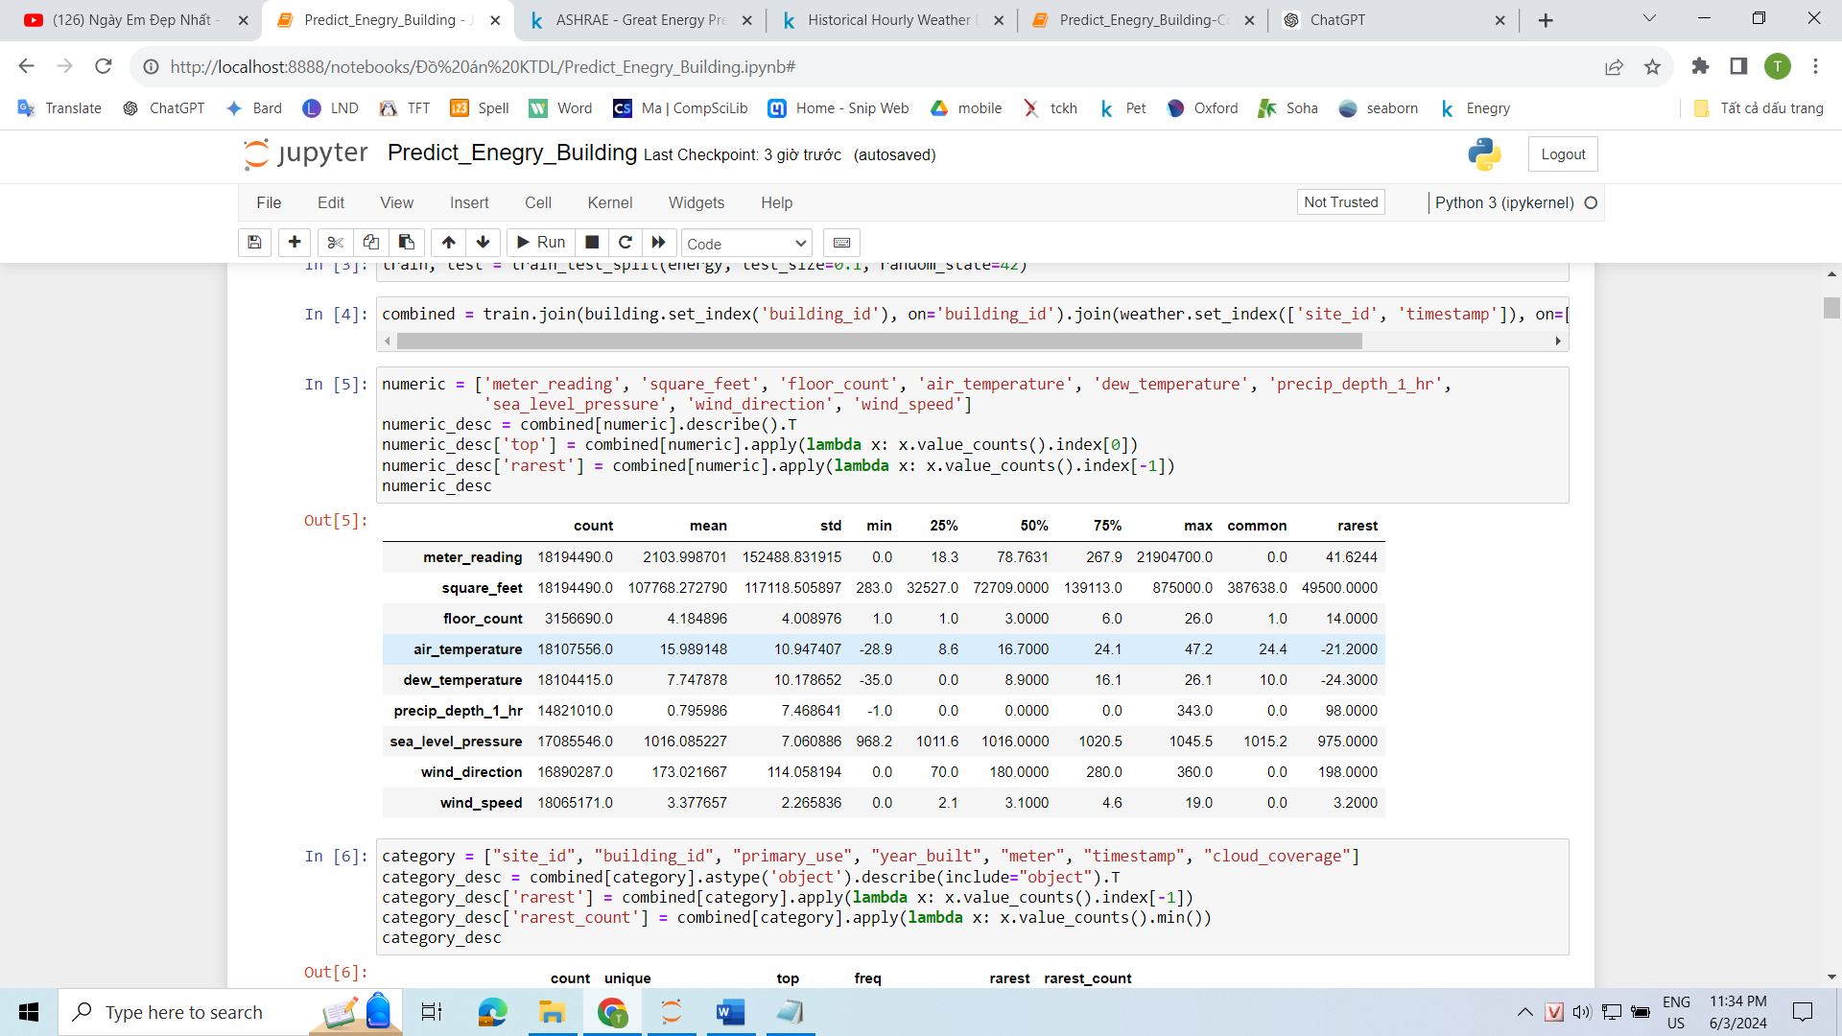

# DATA PREPROCESSING

## Building Data Preprocessing

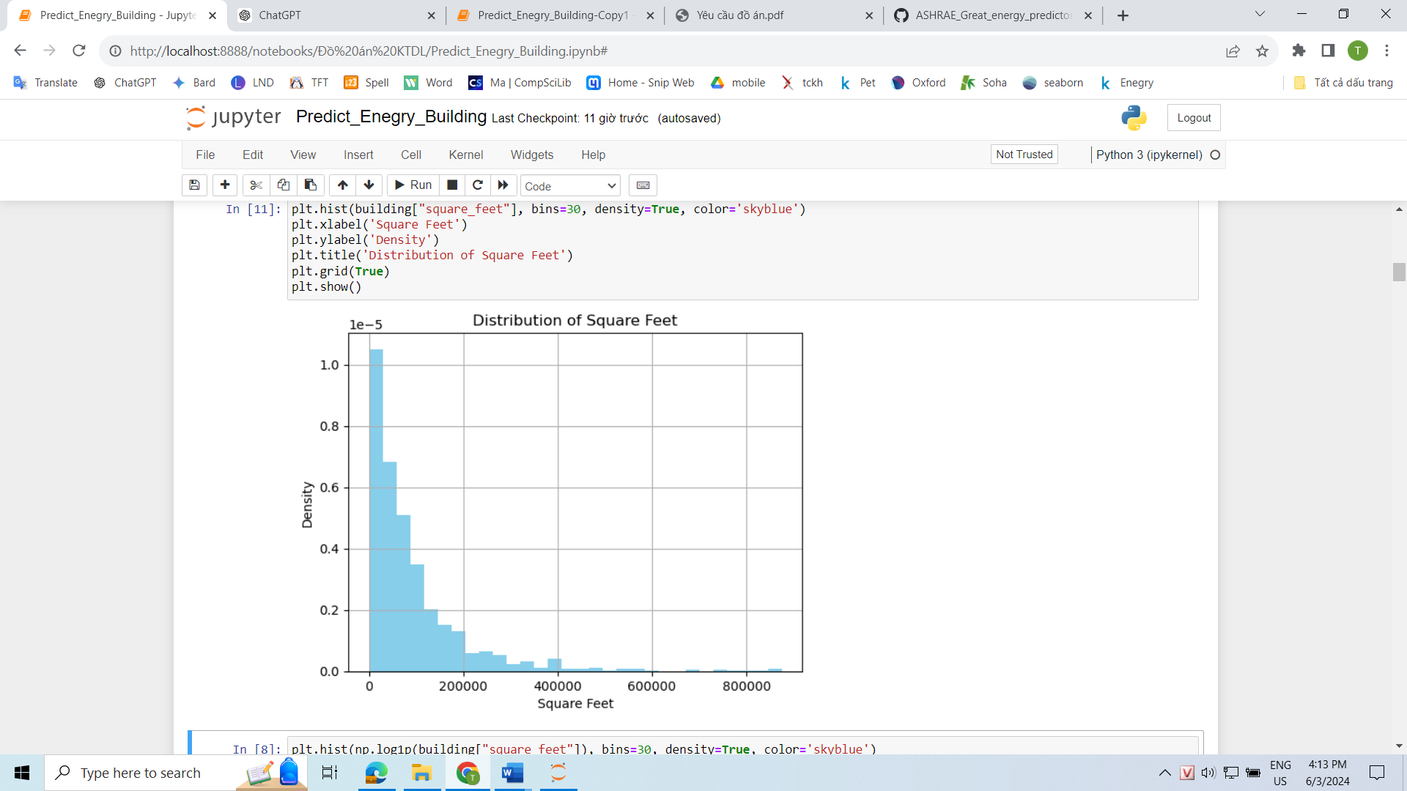

* Upon observing the distribution chart of the square_feet attribute, it is evident that the chart exhibits significant skewness towards one side. Additionally, it is noticeable that the square_feet attribute holds extremely large values, reaching up to 875,000.
* To address the observed skewness and extreme values, the square_feet attribute will be transformed to the log(x) form.

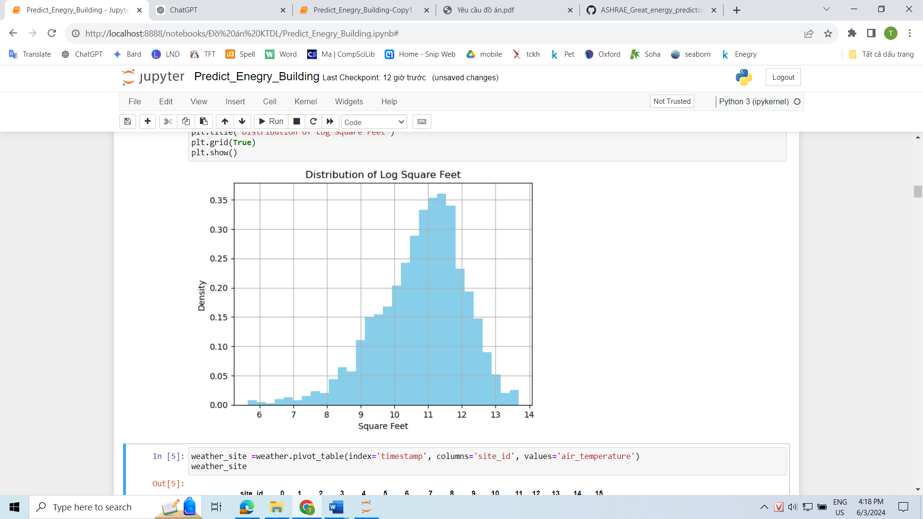

* The variance of the variable “Square_feet” has improved significantly and reduced its deviation.

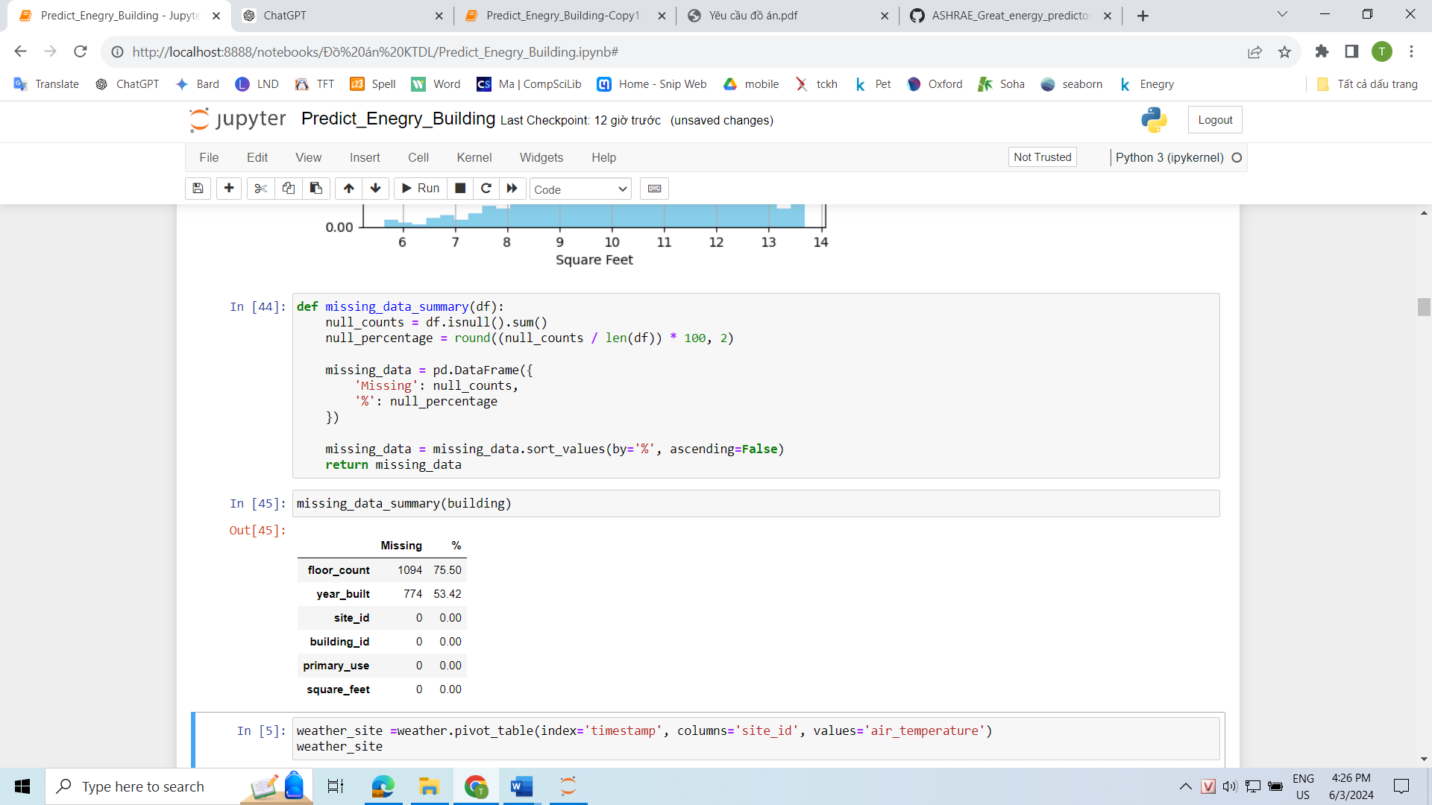

* Observing the quantity and proportion of missing data in the building dataset, we notice that two attributes, namely "floor_count" and "year_built," have a significant amount of missing values, with proportions of 75.5% and 53.42% ( > 50%), respectively.

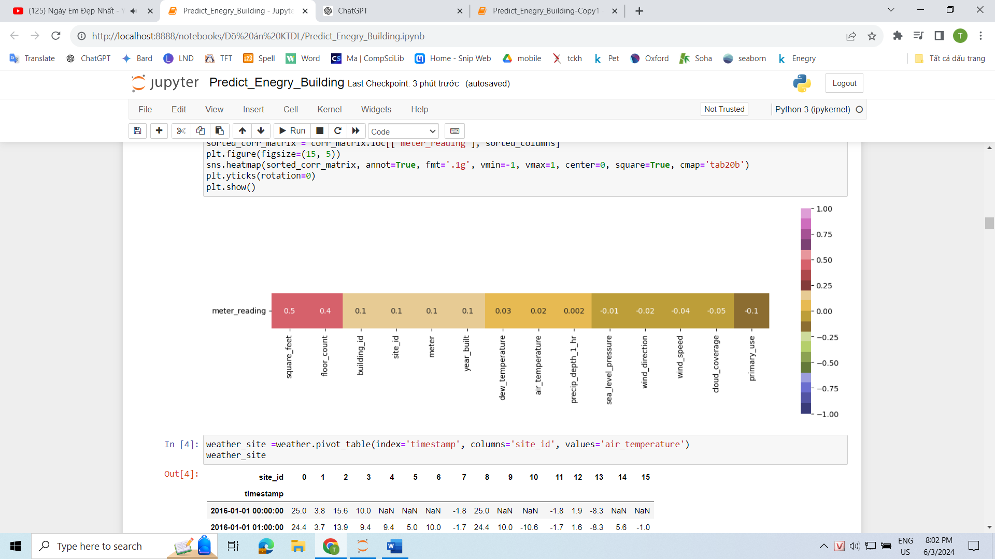

* This is the correlation matrix using the Spearman's rank method between the dependent variable "meter_reading" (the column to be predicted) and the independent variables. We can observe that the "floor_count" variable, despite having many NaN values, has a significant impact on energy consumption.
* Therefore, we will keep the "floor_count" attribute and remove the "year_built" attribute. For the missing NaN values, we will assign a value of -1 to represent the missing data in that row.

## Weather Data Preprocessing

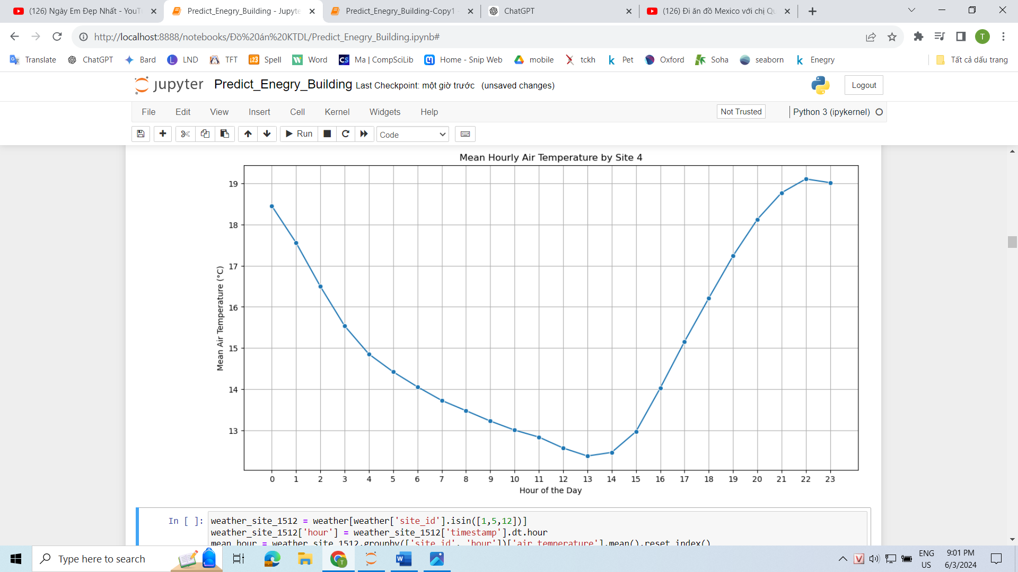

* This is a chart depicting the average temperature throughout the year, broken down by hour, for Site 4. Interestingly, the lowest average temperature occurs between 12-2 PM (midday), while the temperature reaches its peak between 10-12 PM (midnight). Upon further observation of other sites, we notice that many of them exhibit similar peculiar temperature patterns.



* In the dataset source page, the author mentioned that the weather data was obtained from a meteorological station as close as possible to the site. This indicates that the weather data is not their own but could have been acquired through purchase or download from other sources. Furthermore, in the description of the weather data, there is no mention of the timestamp attribute.



* Based on the time deviation when the temperature reaches its peak and considering that ASHRAE is a US-based company with the largest coverage here, we can search for a dataset that includes air temperatures from 2012-2017 for cities in the United States, Canada, Israel, and more. Additionally, this dataset should provide temperature values at an hourly resolution.
* We will utilize this dataset to accurately determine the timestamps by examining the correlation between the different sites and cities. Determining the city will help us account for the time difference accurately.

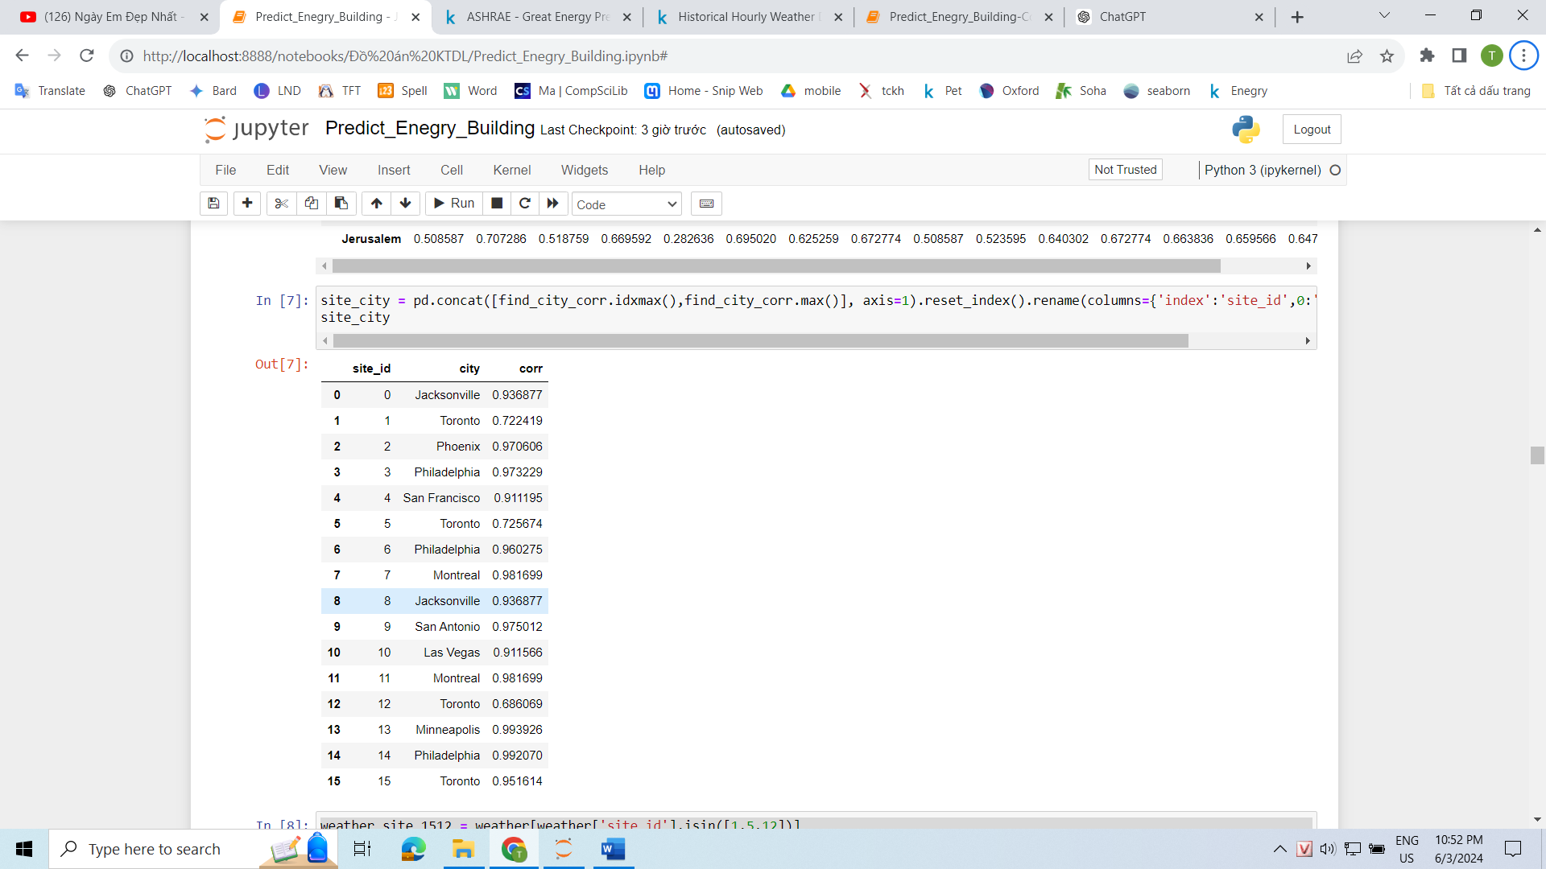

* For pairs of site-city with a correlation coefficient above 0.9, we can assume that the site corresponds to that particular city. In this case, we observe that there are three site IDs: 1, 5, and 12, with correlation coefficients around 0.7.
* Let's proceed to re-evaluate the average temperature charts for each hour of Site 1, Site 5, and Site 12.

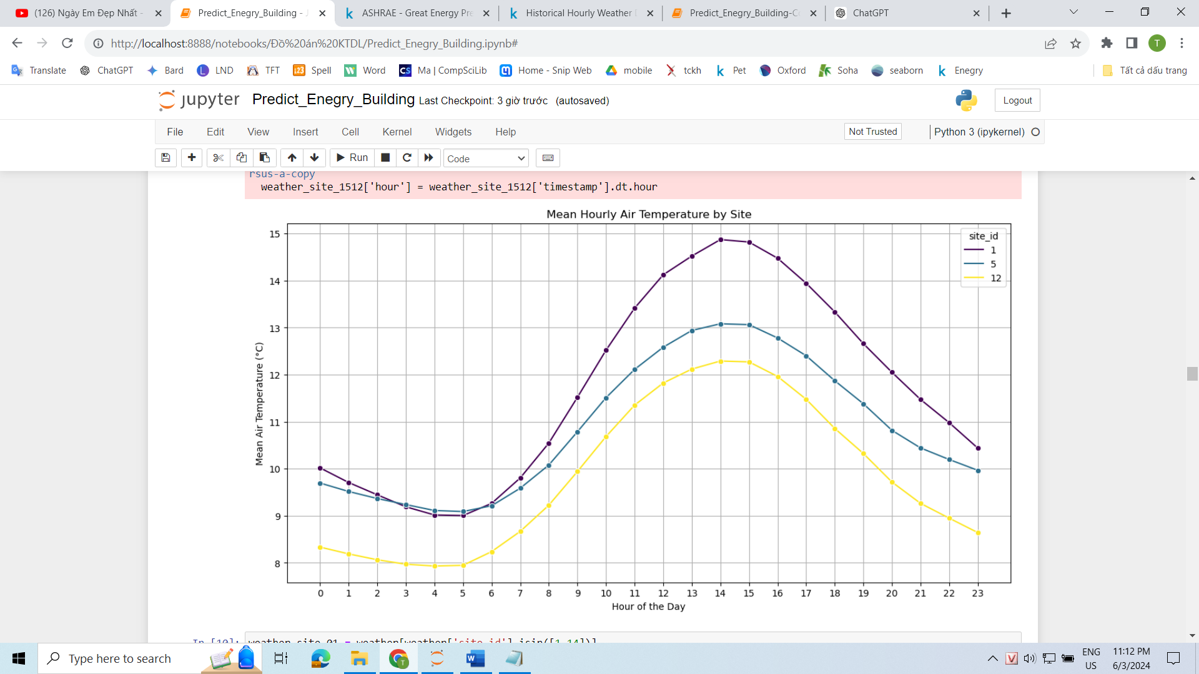

* We can observe that all three sites seem to share a similar time zone, with the temperature reaching the lowest point between 3-6 AM and peaking between 1-4 PM.
* Let's proceed with comparing one of these three sites with the sites that have been identified with their respective cities.

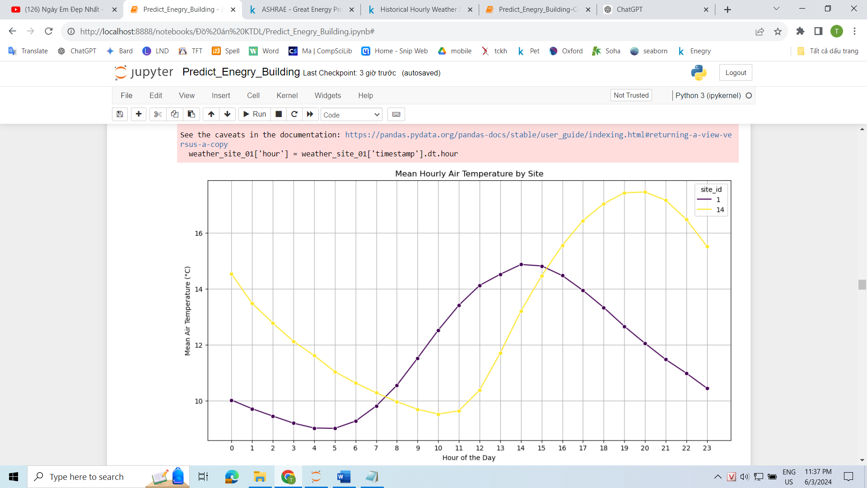

* We will select Site 14 for comparison because it has a very high correlation with its respective city, reaching 0.99. Philadelphia is a city in the United States with a GMT offset of -5.
* Observing Site 14, we can see that the lowest and highest temperatures occur between 8-11 AM and 6-9 PM, respectively. On the other hand, for Site 1, the lowest and highest temperatures occur between 3-6 AM and 1-4 PM.
* As a result, we can deduce that Site 1 corresponds to a GMT offset of 0 (8-5 = 3-0). Considering a few other sites in addition to Site 14, we can narrow down the range of the GMT offset to either -1 or 0.

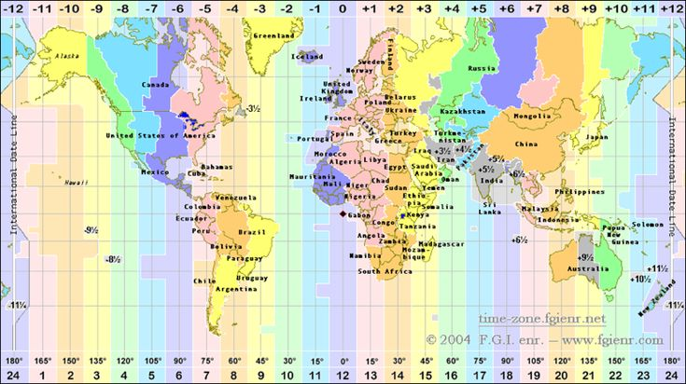

* Based on the world GMT map, we have identified the countries that fall within these two time zones.





* This is a map of the cities and regions where the Ashare Corporation operates. We can observe that the areas with GMT offsets of -1 and 0 encompass six cities, namely: Dublin in Ireland, Loughborough and London in the UK, Madrid in Spain, Lisbon in Portugal, and Lagos in Nigeria.

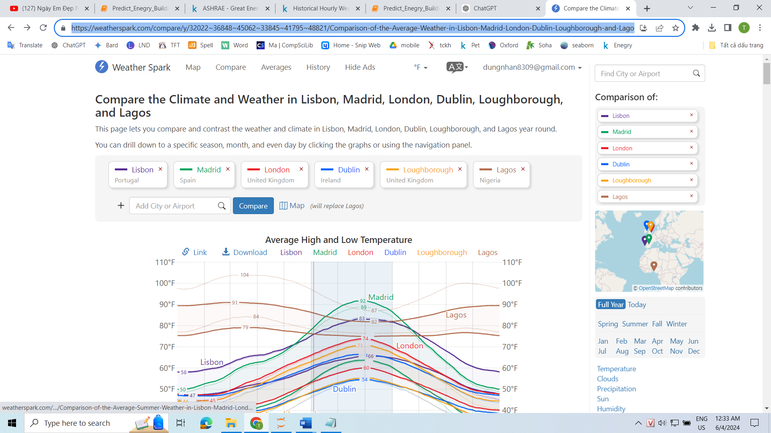

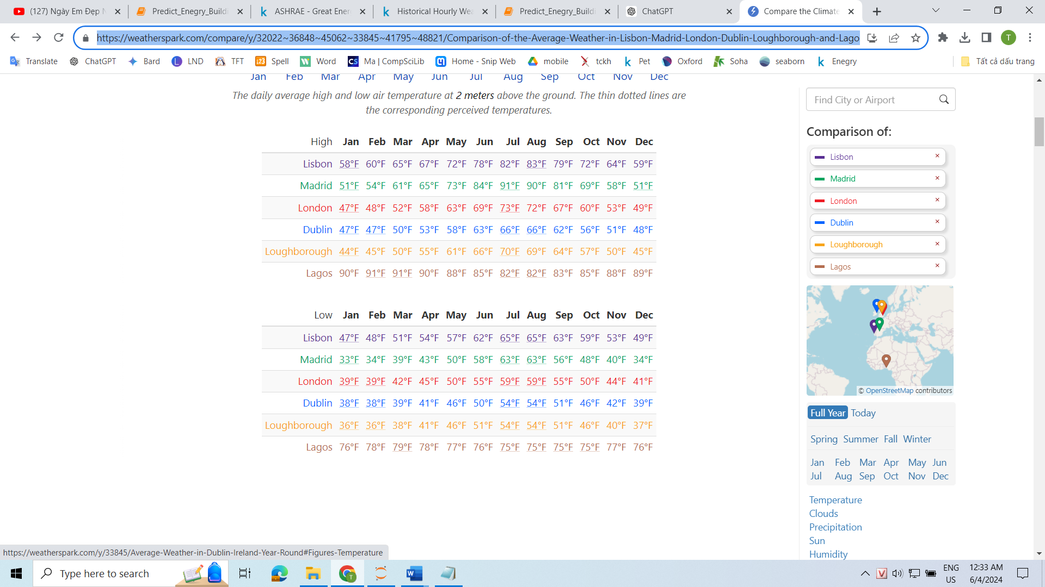

* Here is the air temperature data for the year 2016 for the six cities mentioned above. The data is provided by the website Weatherspark.
* The converted temperature ranges for each city are as follows:
* Lagos [28-31] , Lisbon [16-21] , Madrid [10-20]
* London [9-15] , Dublin [8–13] , Loughborough [8-12]



* Based on the temperature charts of the three sites earlier, we can observe that the average temperature for all three sites falls within the range of [8-15] degrees Celsius.
* Therefore, we can confidently conclude that Site 1 corresponds to the city of London, Site 5 corresponds to Loughborough, and Site 12 corresponds to Dublin.
* Since we can determine the city, the "holiday" attribute becomes significant. However, relying solely on slight differences in air temperature to immediately identify the city may not be feasible, as these three sites have quite similar temperature patterns.

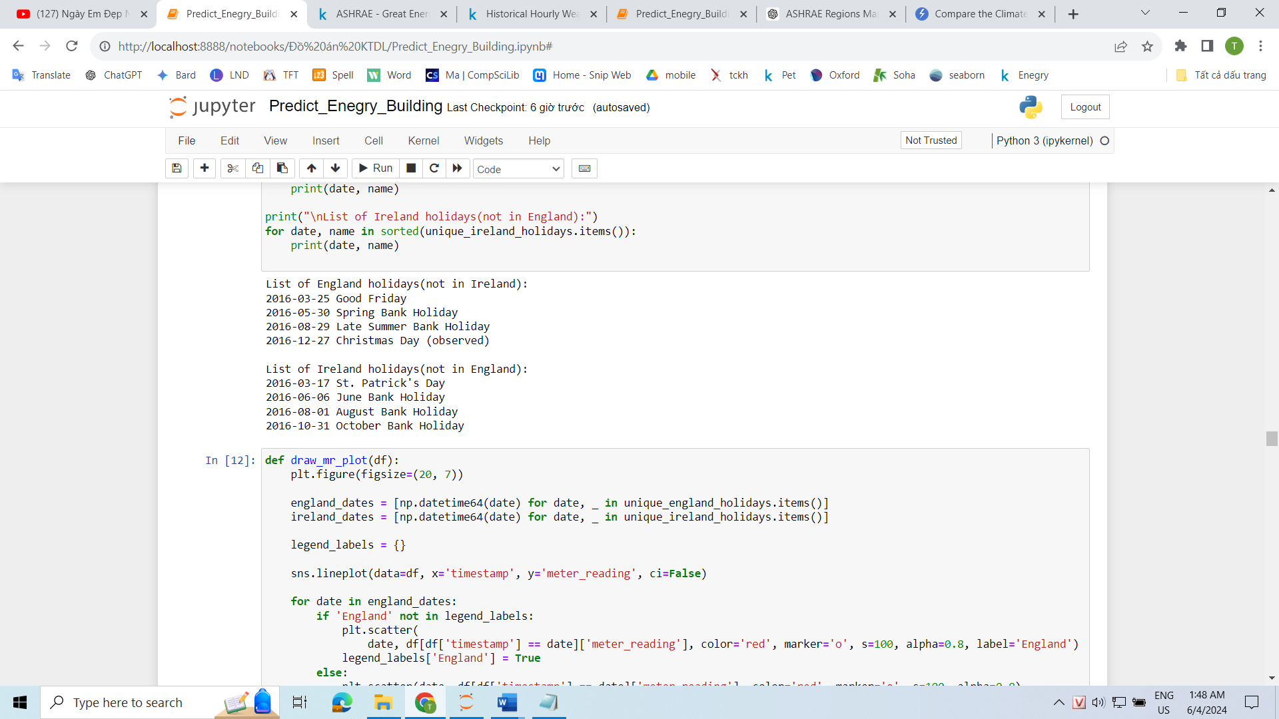

* As mentioned earlier, holidays have a significant impact on the electricity consumption of buildings. Therefore, let's proceed to determine how holidays affect the sites.
* Both London and Loughborough are located in the England region of the UK, while Dublin is in Ireland. By utilizing the holiday library, we can identify the holidays specific to these two countries without any overlap.



* To easily observe the impact, let's focus on buildings with the primary_use attribute set as "Education." Additionally, Education is the most common primary_use category, accounting for 40.39% of the buildings.
* We will exclude weekends since they may not provide significant insights, as Saturdays and Sundays are typically non-school days. Excluding weekends will also help reduce the data volume and prevent cluttering the charts.

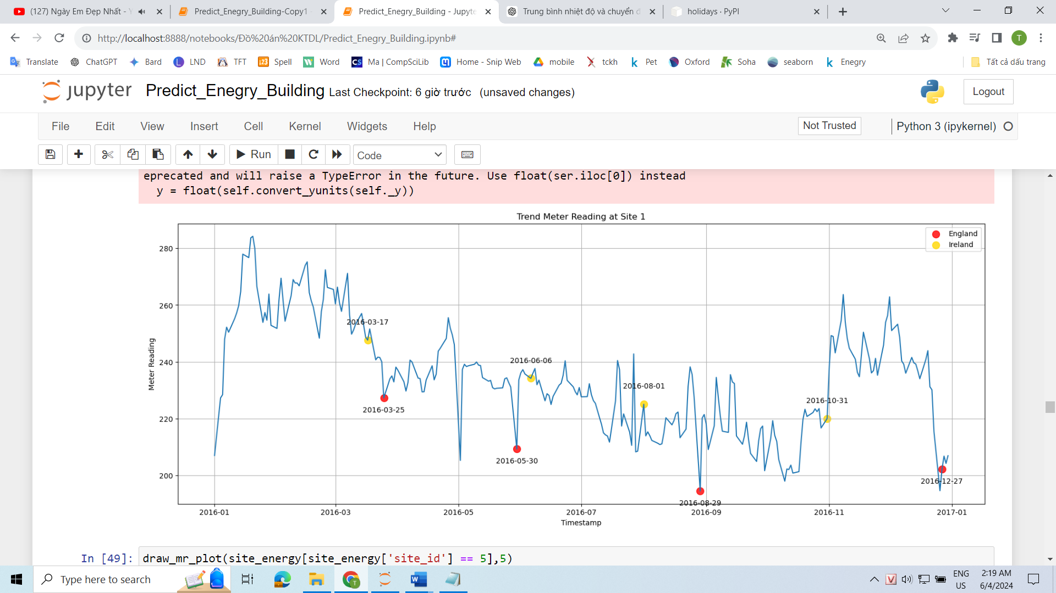

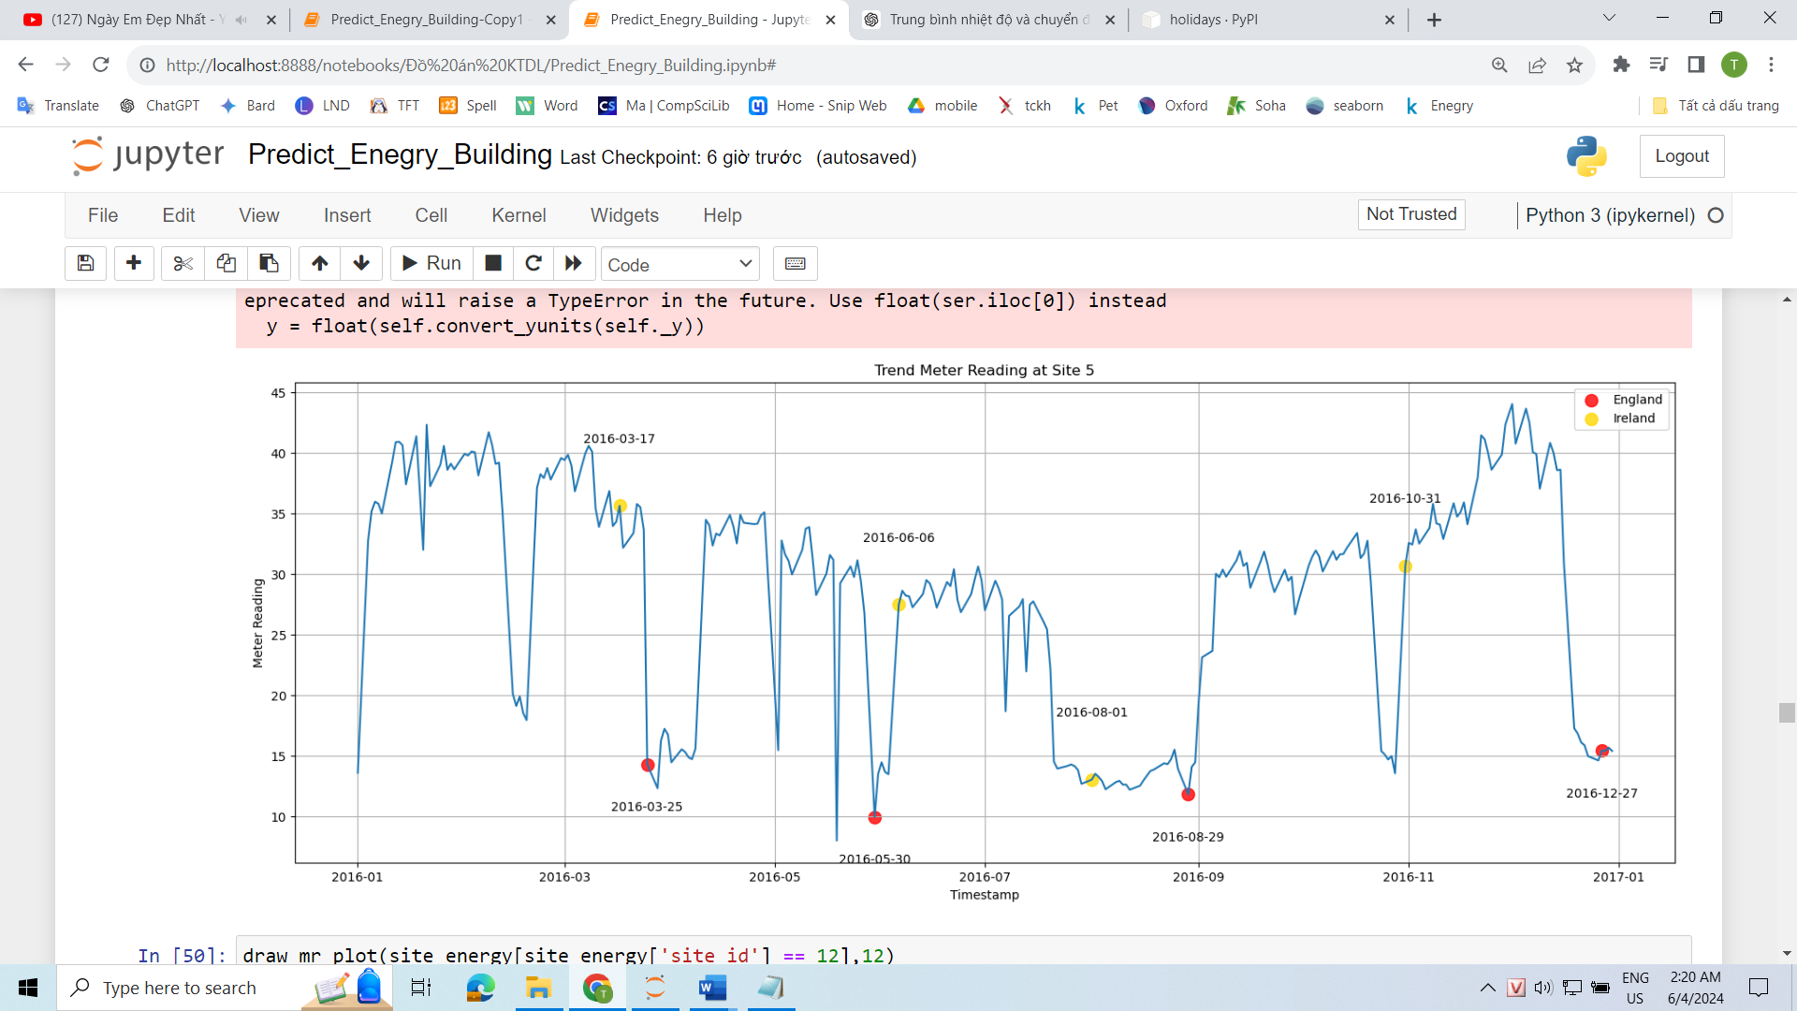

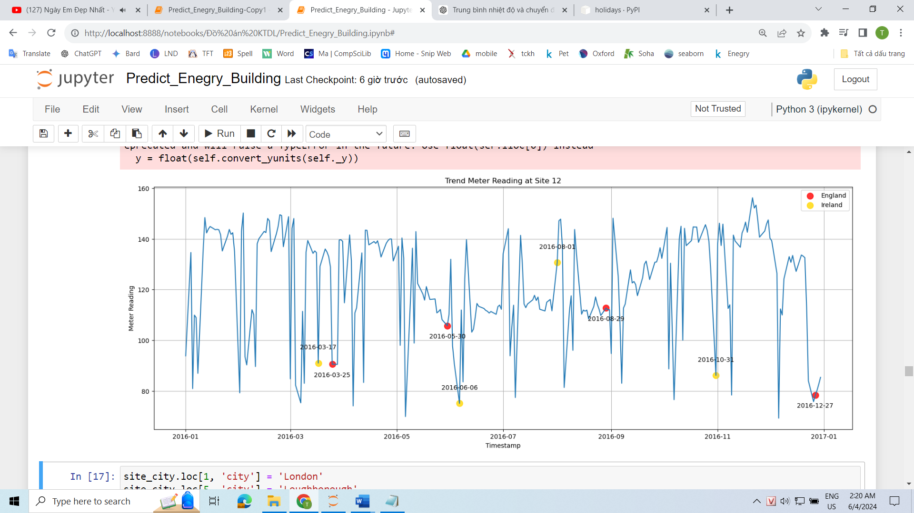

* At Site 1 and Site 5, we can observe a significant decrease in meter_reading on the four public holidays of England.
* At Site 12, there are specific holidays of Ireland where meter_reading also experiences a notable decrease.
* Therefore, we can infer that Site 12 corresponds to the city of Dublin, while Site 1 and Site 5 are not as crucial in determining the city. Since what we need is the GMT offset to adjust the timestamp and country for holiday identification, we can assume that Site 1 represents London and Site 5 represents Loughborough. This assumption is based on the air temperature chart, where the air temperature in London is higher than in Loughborough.

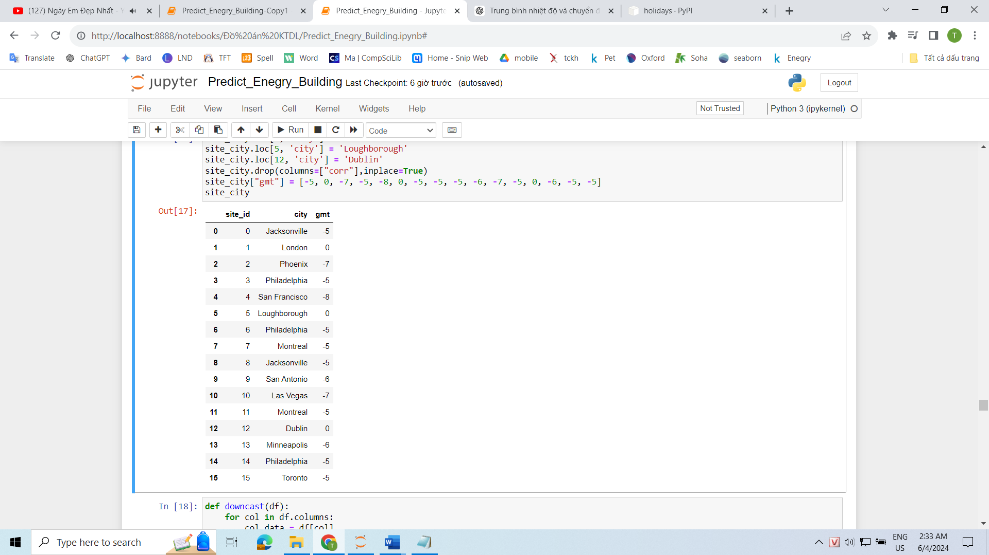

* Here is a list of site_ids along with their corresponding city names and GMT offsets

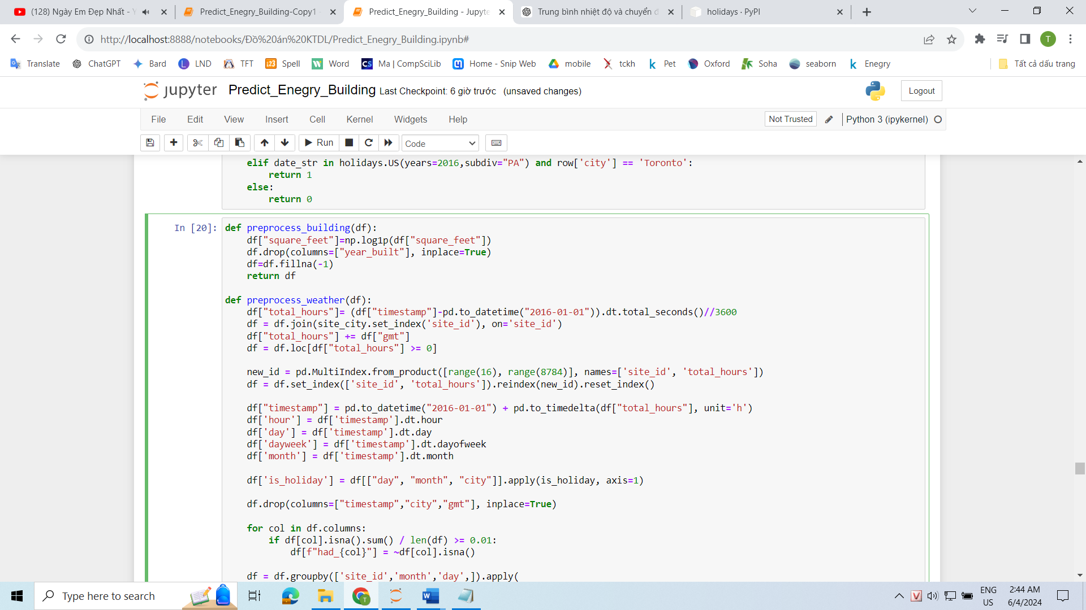

* Taking 2016-01-01 00:00:00 as the reference point, we can create the attribute "total_hours." This attribute will combine with the GMT offset to eliminate time discrepancies. We will then remove any rows where total_hours < 0 since those rows belong to the year 2015.

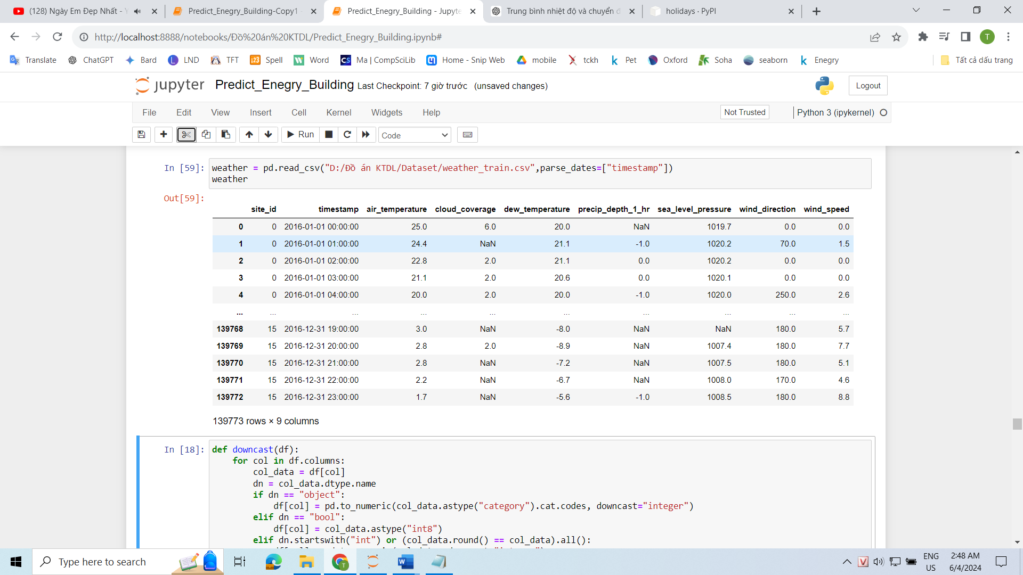

* This is the raw weather data, which has not been processed yet. We can see that this weather data contains a total of 139,773 rows.
* However, based on the calculation: 16 (site_id) * 366 (day) * 24 (hour) = 140,544 rows, it suggests that the weather data originally does not have data for certain days.
* Therefore, it appears that some days are missing from the weather data.

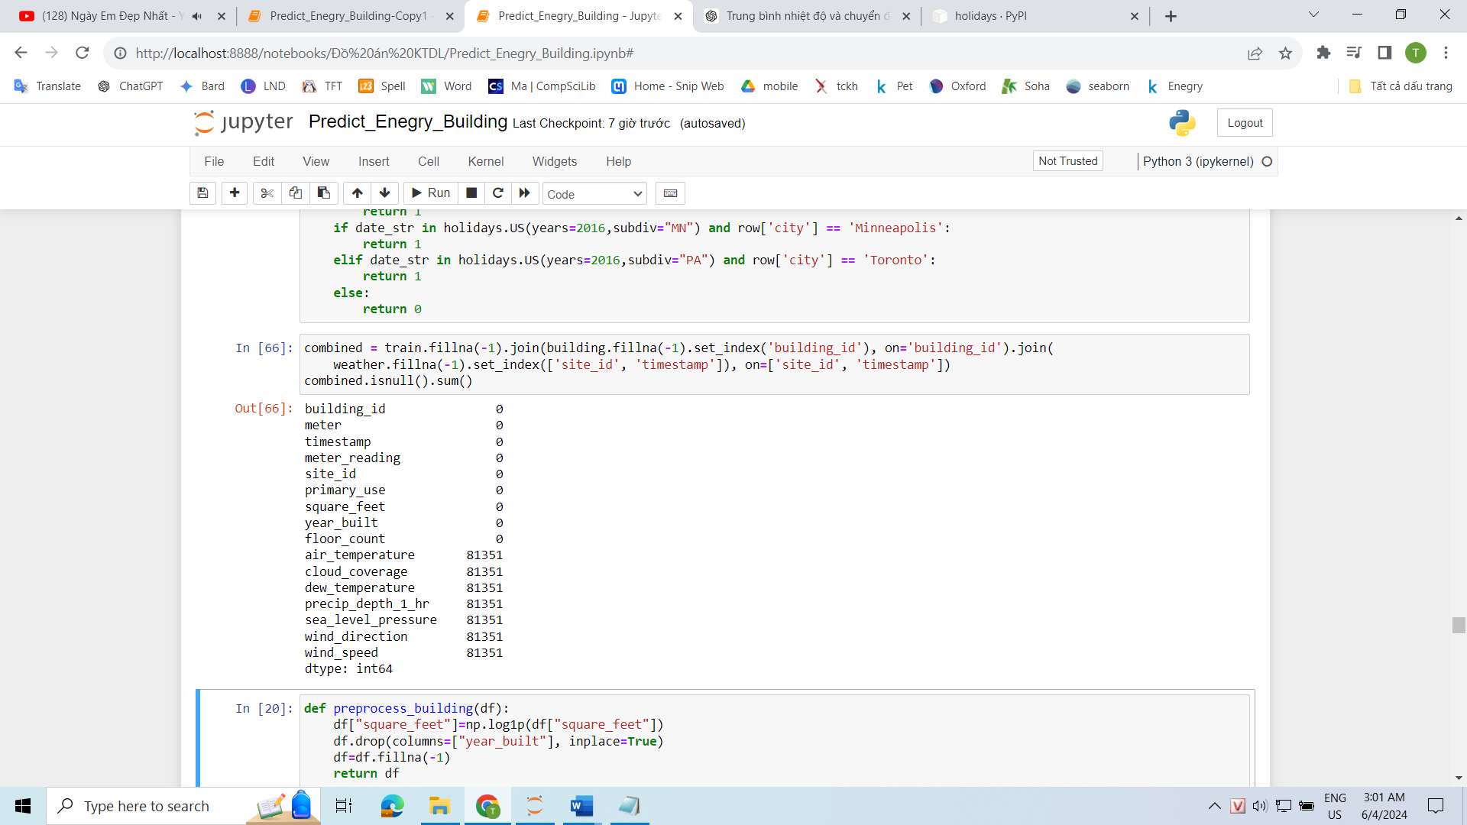

* This can lead to mismatches when joining the weather data with the training data, as there might be timestamps in the training data that do not exist in the weather data. As a result, some rows in the training data may have NaN values for weather attributes.
* To address this issue, we can use the reindex method to fill in the missing rows in the weather data for site_id ranging from 0 to 15 and total_hours ranging from 0 to 8784.
* Once the reindexing is done, we can plot a graph to visualize the relationship between the timestamp and meter_reading using the new timestamp values.

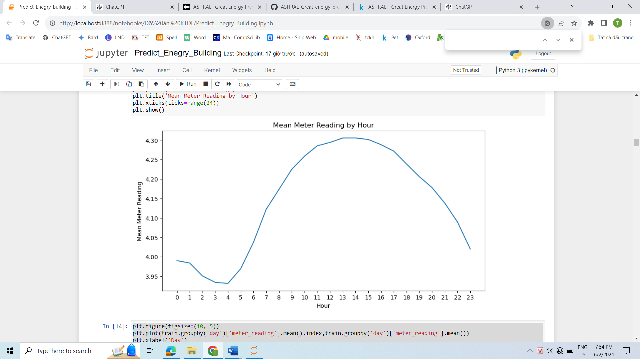

* It can be observed that energy usage gradually decreases towards the late night and early morning hours. It then starts to increase and reaches its peak during midday and afternoon. This pattern is easily understandable as during the night, people are typically asleep and engage in fewer energy-consuming activities. On the other hand, during midday and afternoon, which are peak hours of sunlight and heat, there is a higher demand for energy usage due to the use of various energy-consuming devices.

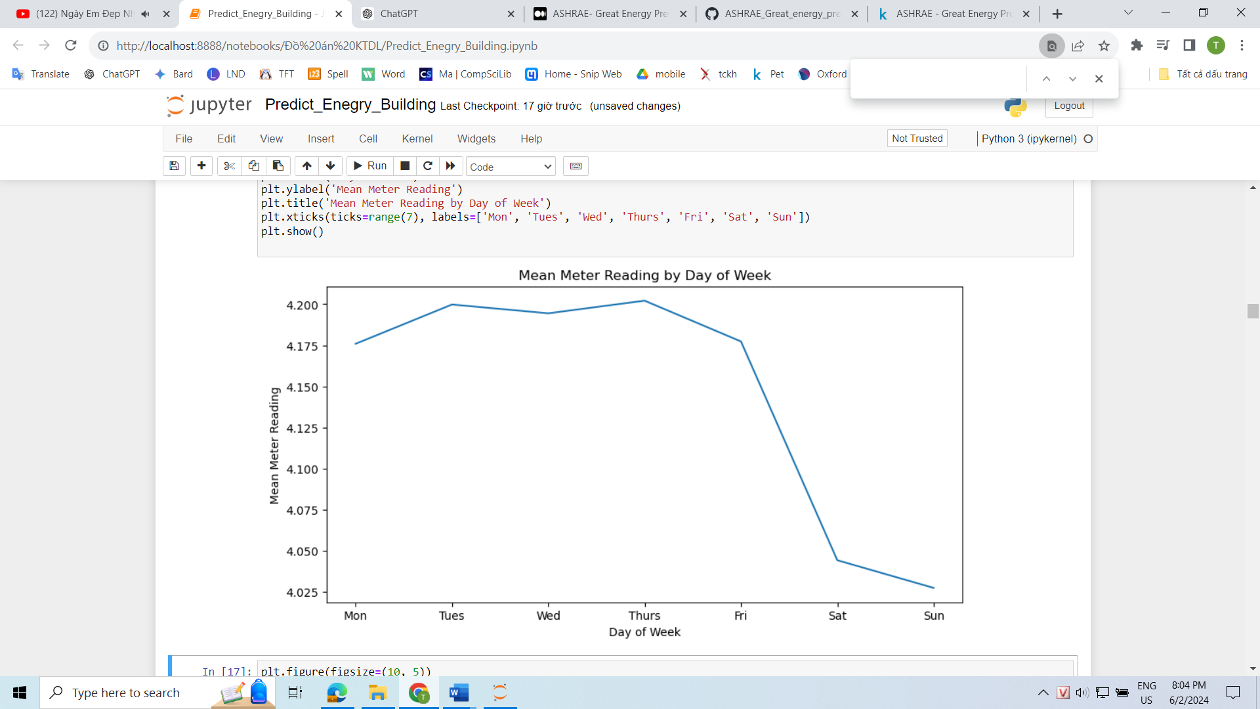

* It can be observed that meter_reading on Saturdays and Sundays is significantly lower compared to weekdays. This occurs because Saturdays and Sundays are typically designated as weekends, and activities that consume energy in buildings, offices, and business establishments decrease significantly compared to weekdays when people are working.

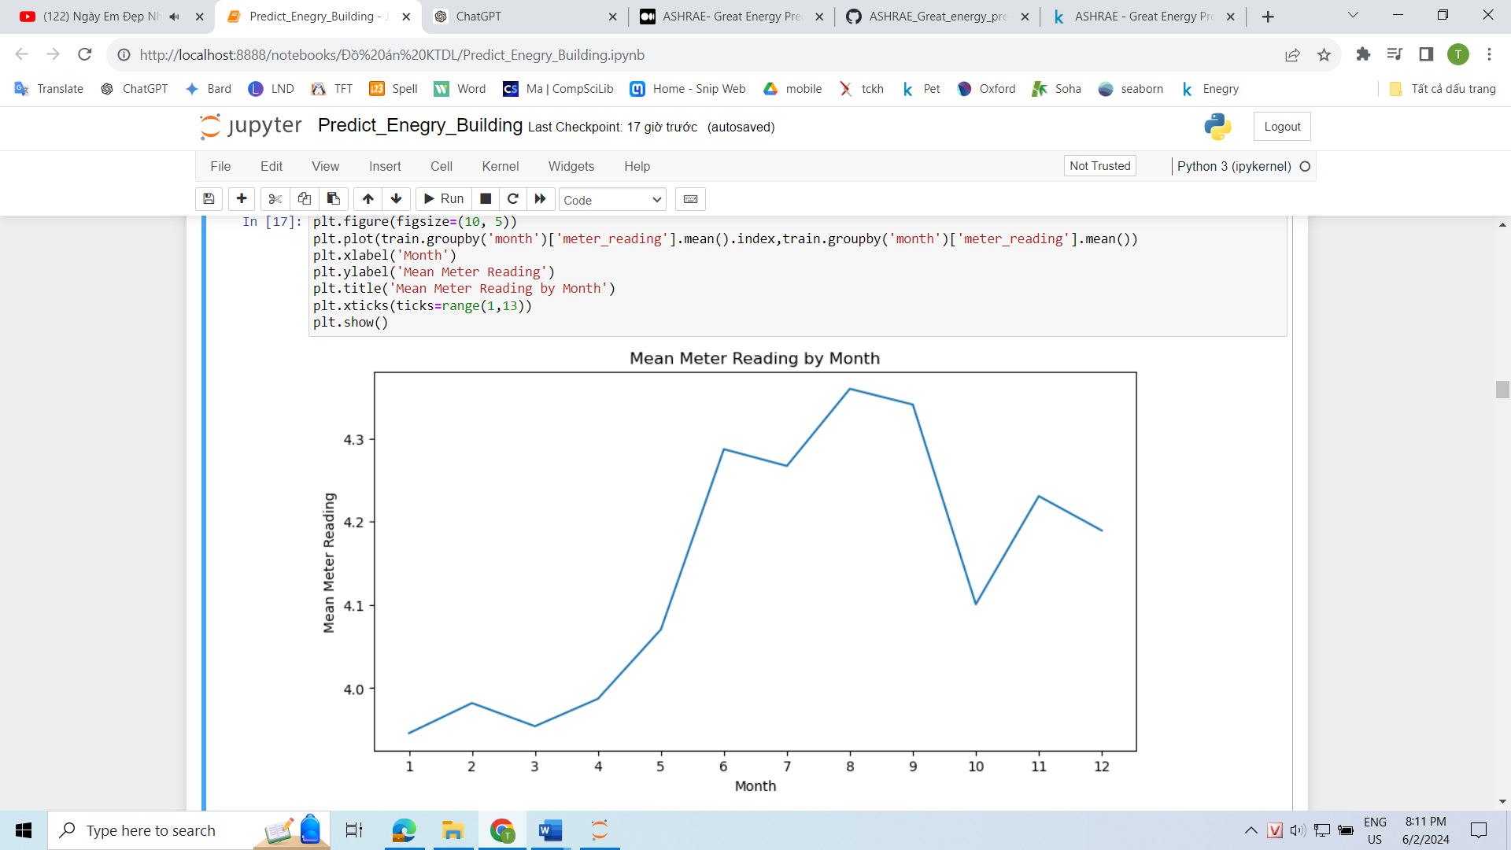

* It can be observed that meter_reading shows distinct variations throughout the months. During the summer months, when the weather is hot, there is an increase in energy consumption due to the higher usage of cooling devices. Conversely, during the winter months, meter_reading decreases significantly due to reduced demand for cooling devices.

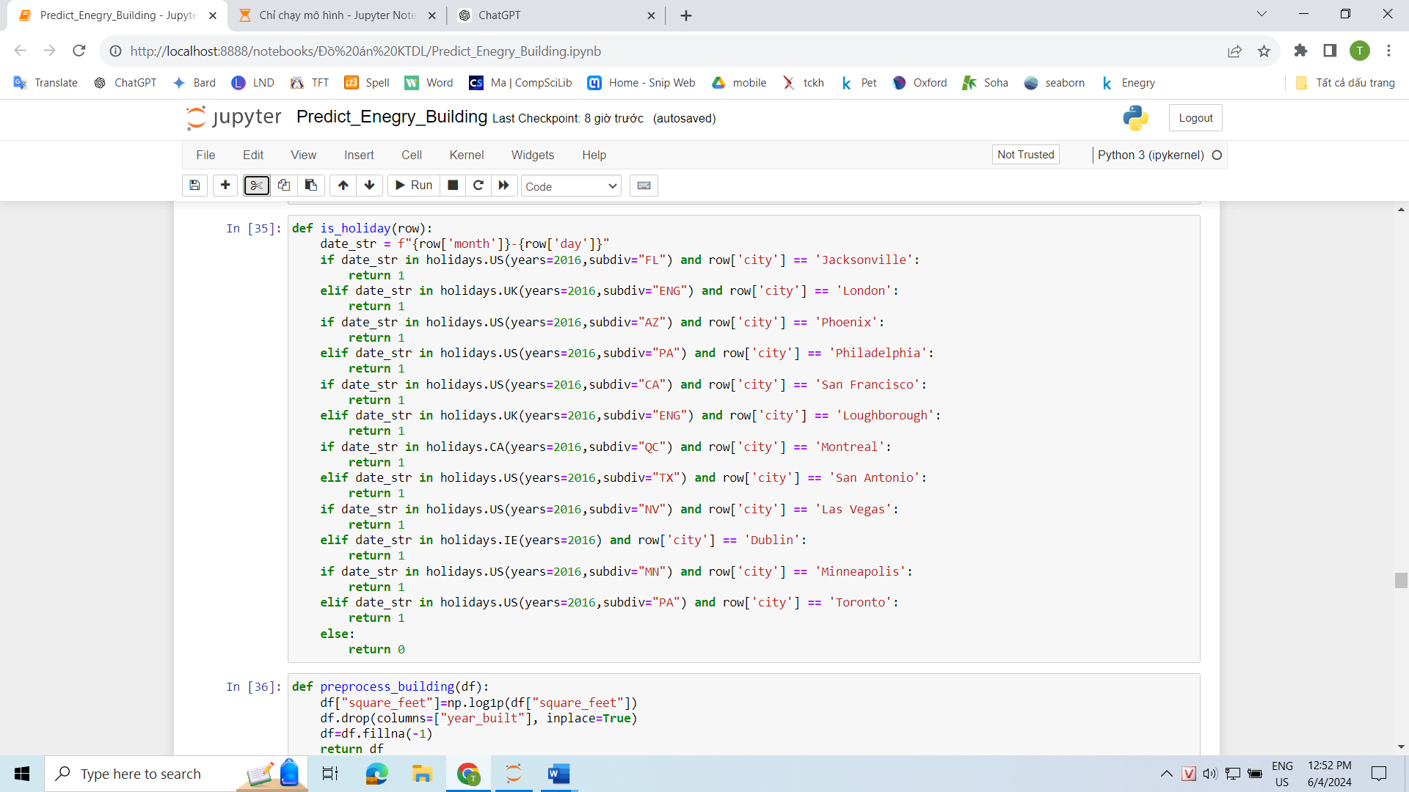

* Determining whether a particular day is a holiday is also crucial. By using the holiday library, we can identify the specific holidays for each region corresponding to the city.

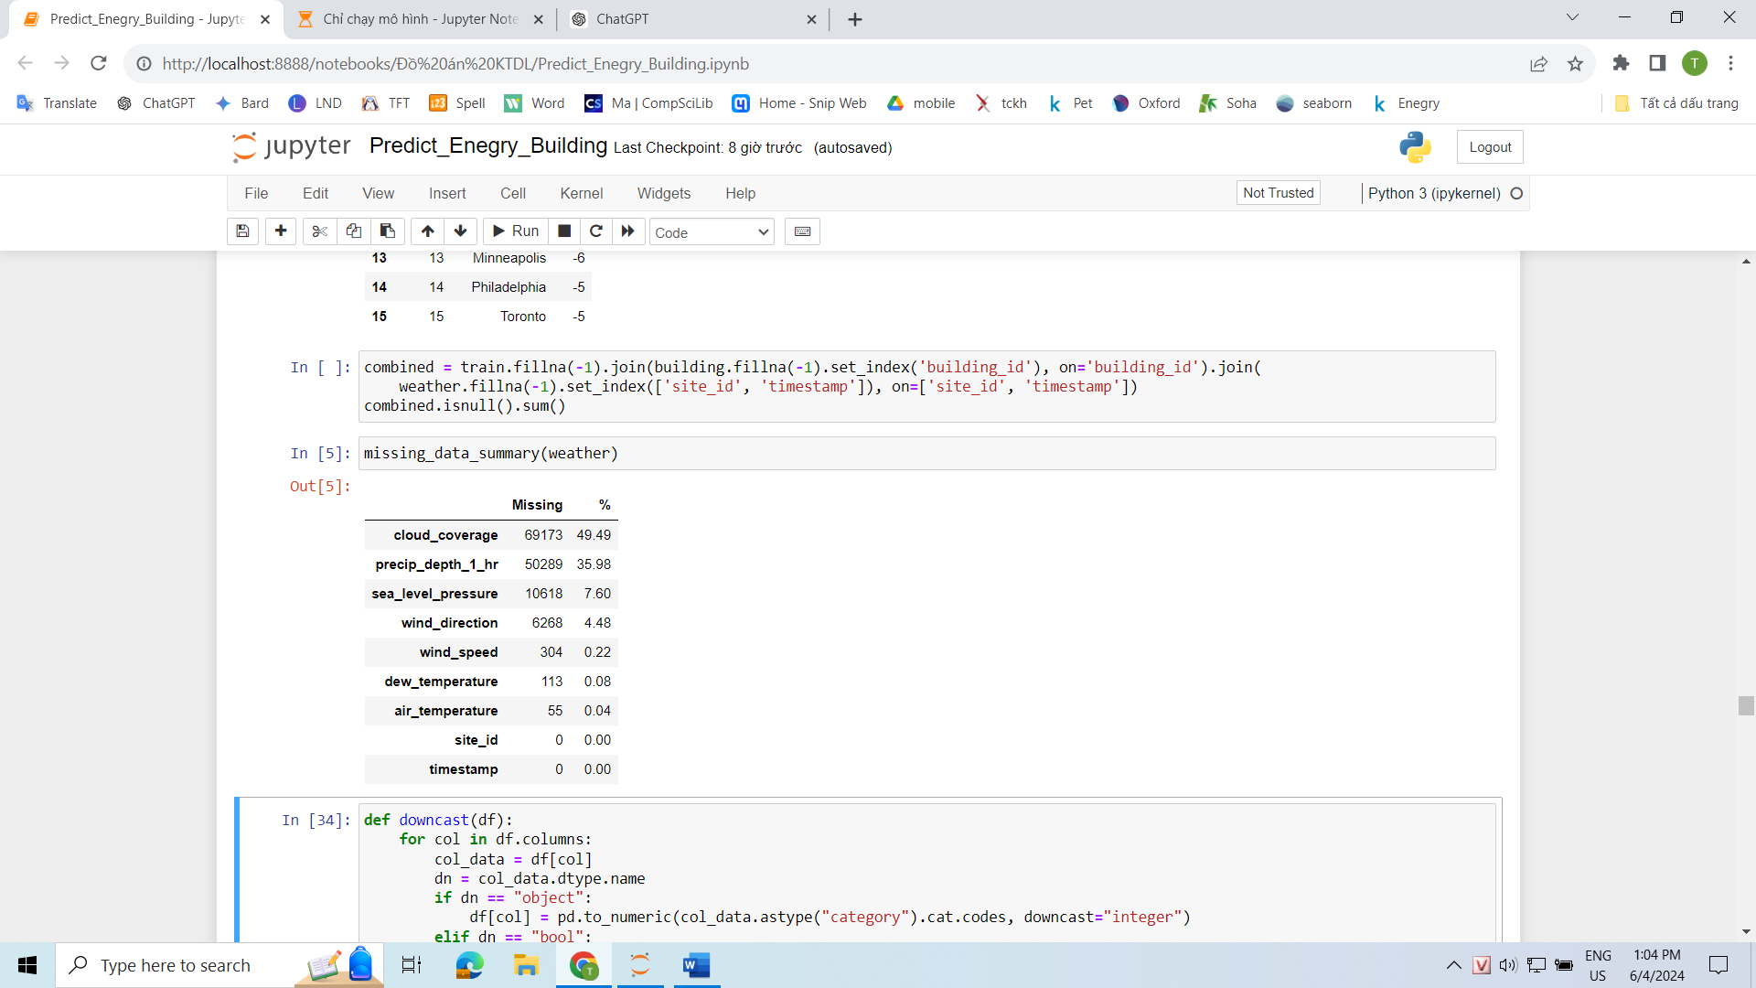

* Since all attributes have a missing rate of less than 50%, we will keep all of these attributes and use appropriate methods to fill in the NaN values.

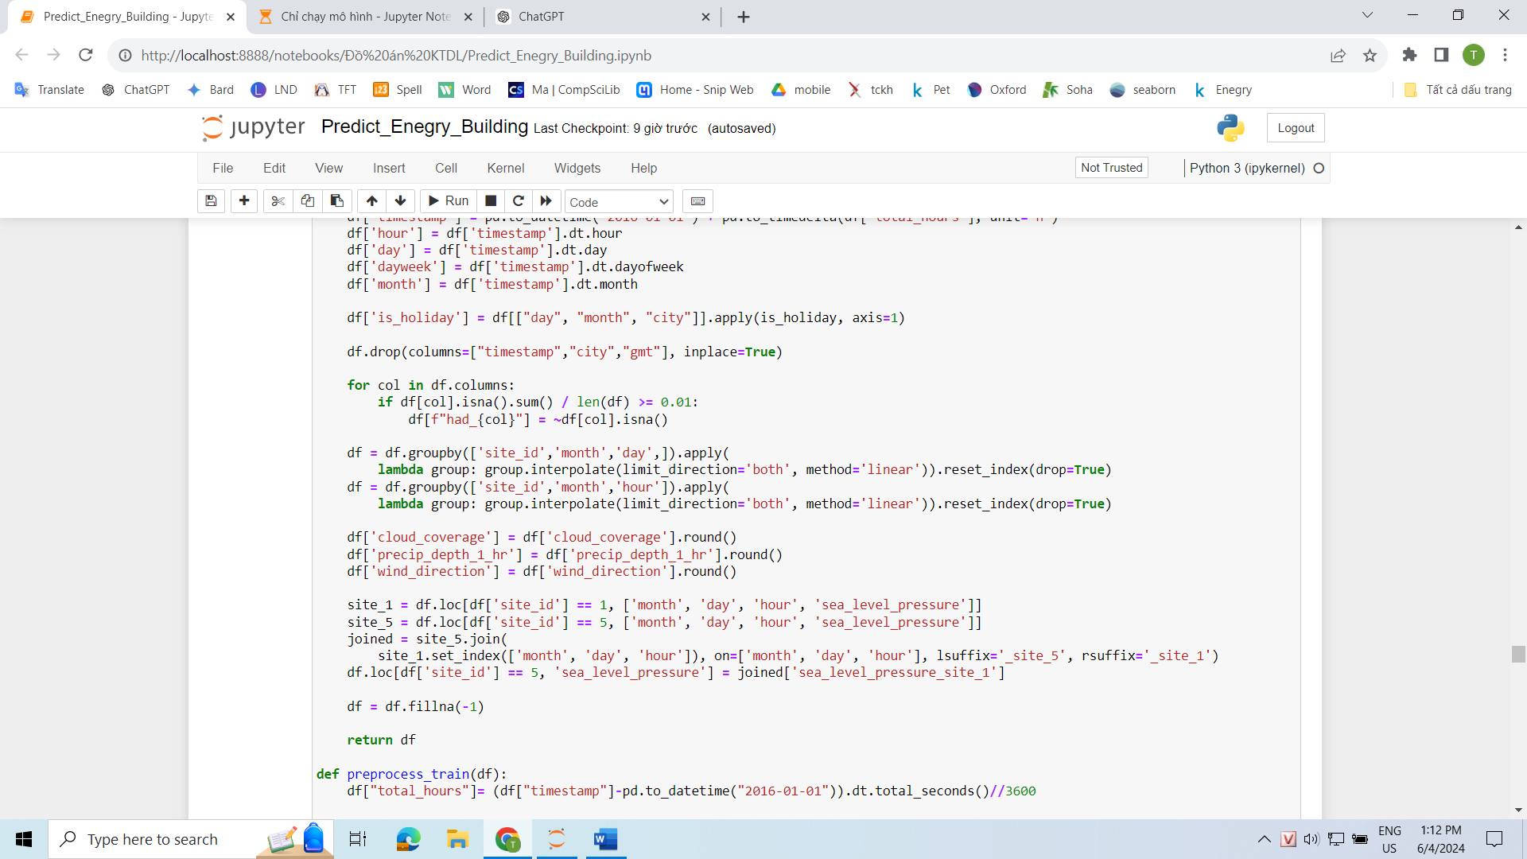

* To avoid any potential confusion where the machine learning model may interpret the filled values as actual data, we can create a new column to indicate whether the values in a particular row for a column with a missing rate greater than 1% are actual values or filled values.

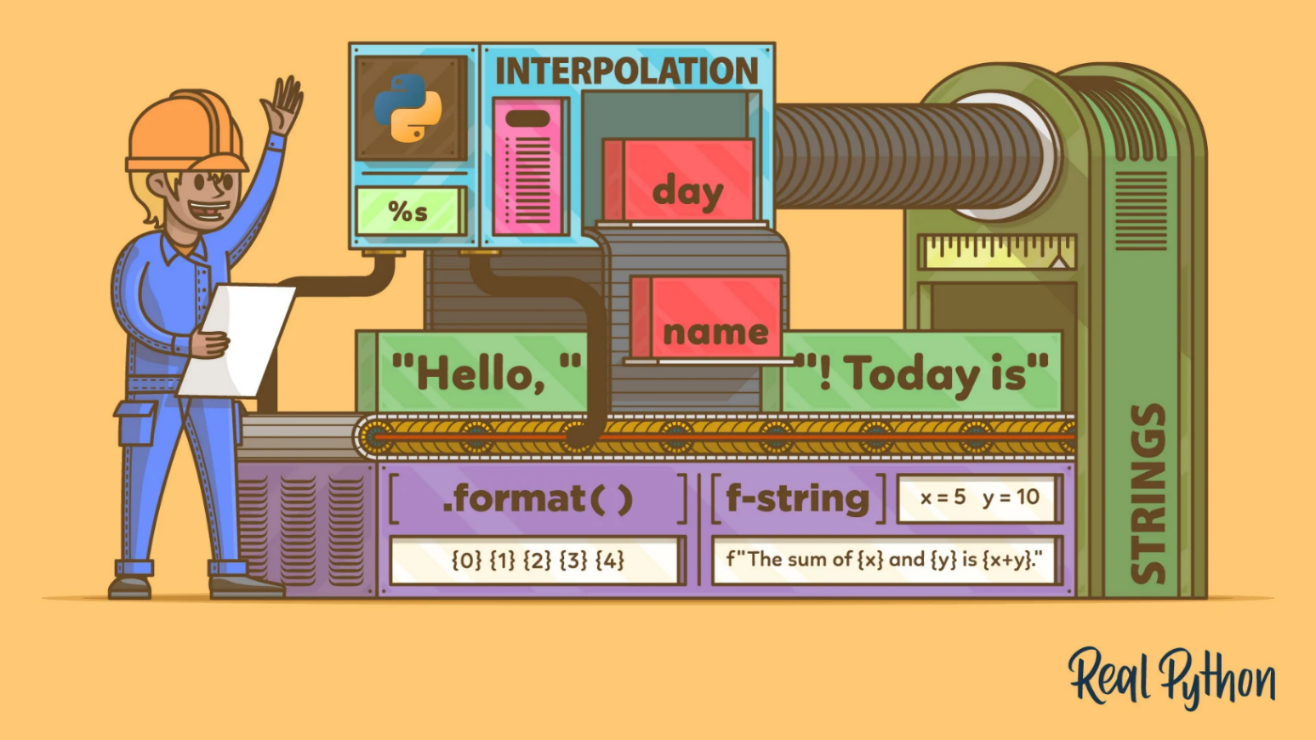



* Since this is time series data, the rows are likely to be related to each other, especially in the weather data. The weather conditions for the same site on the same day are likely to be correlated.
* Therefore, we can use the interpolate technique to fill in the missing NaN values. We will apply this technique specifically to rows with the same site and the same hour. This is because the weather conditions at 1:00 AM on January 1, 2016, are likely to be similar to the weather conditions at 1:00 AM on January 2, 2016.

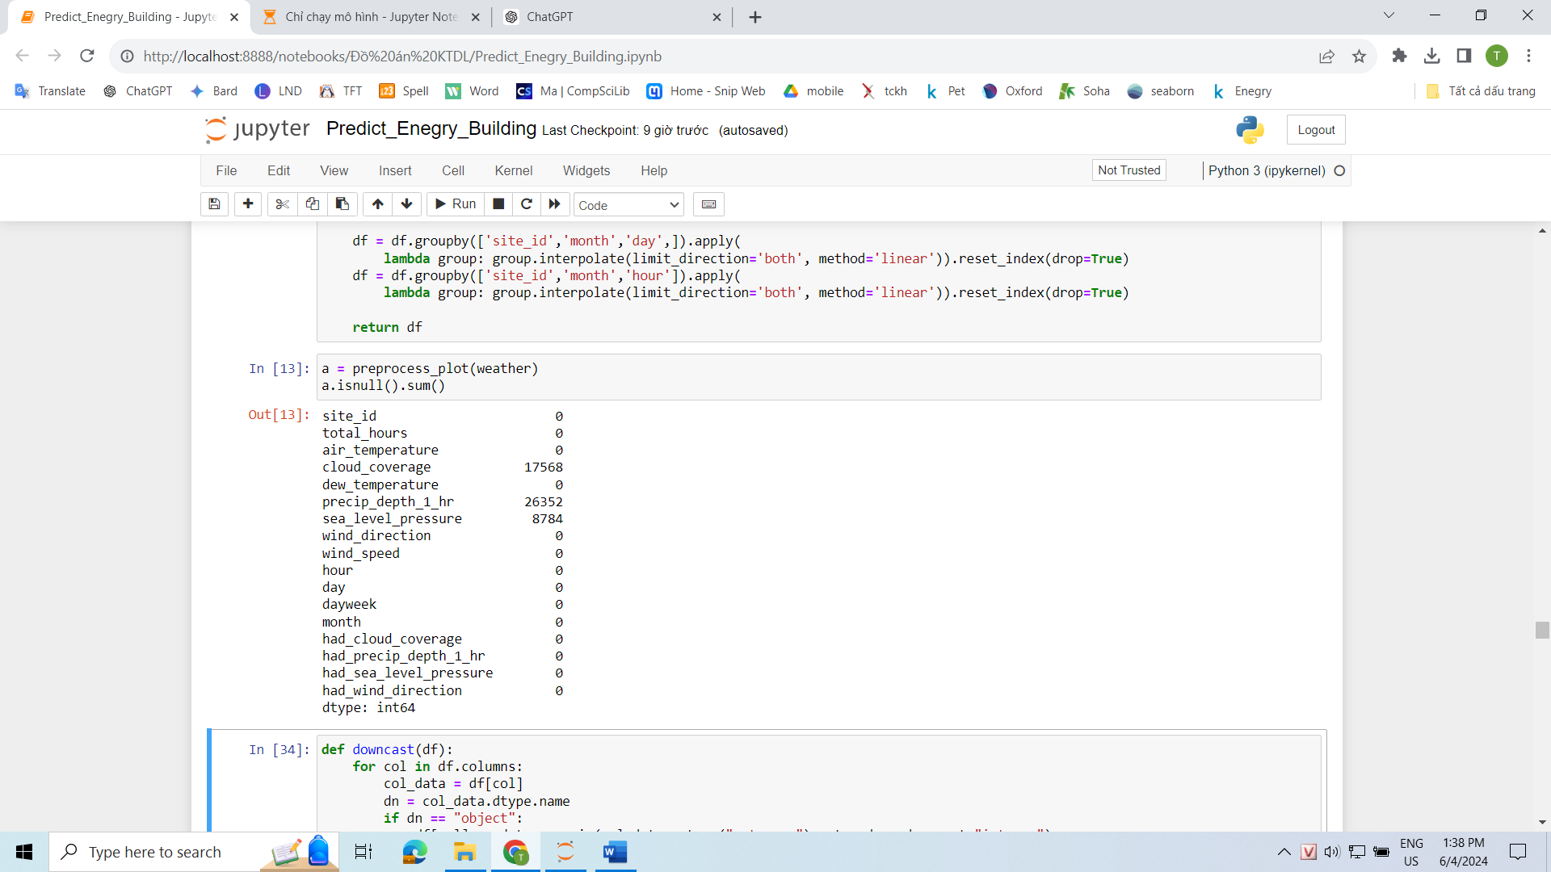

* After using the interpolate method to fill in the missing NaN values, we still observe that some columns have remaining missing values. Upon closer examination, we can see that these missing values occur at multiples of 8784 (366 days * 24 hours).
* The reason for this is that the weather data does not have any data for this specific site and column combination throughout the 366 days, resulting in all values being NaN. Consequently, the interpolate method cannot generate meaningful values and still produces NaN values for these specific cases.

|  |  |  |  |
| --- | --- | --- | --- |
|  | Cloud_coverage | Precip_depth_1_hr | Sea_level_pressure |
| Site 1 |  | ✅ |  |
| Site 5 |  | ✅ | ✅ |
| Site 7 | ✅ |  |  |
| Site 11 | ✅ |  |  |
| Site 12 |  | ✅ |  |

* This is the table after analyzing the rows with NaN values and identifying the corresponding columns and sites. As determined earlier, there are 16 sites in total, with 11 sites in the United States, 3 sites in Europe, and 2 sites in Canada.
* As observed, the attribute "cloud_coverage" is missing for sites 7 and 11, which are the only two sites in Canada. The attribute "precip_depth_1_hr" is missing for all three sites in Europe.
* This indicates that the weather data source for Canada does not provide the "cloud_coverage" attribute, and the weather data source for Europe does not include the "precip_depth_1_hr" attribute.

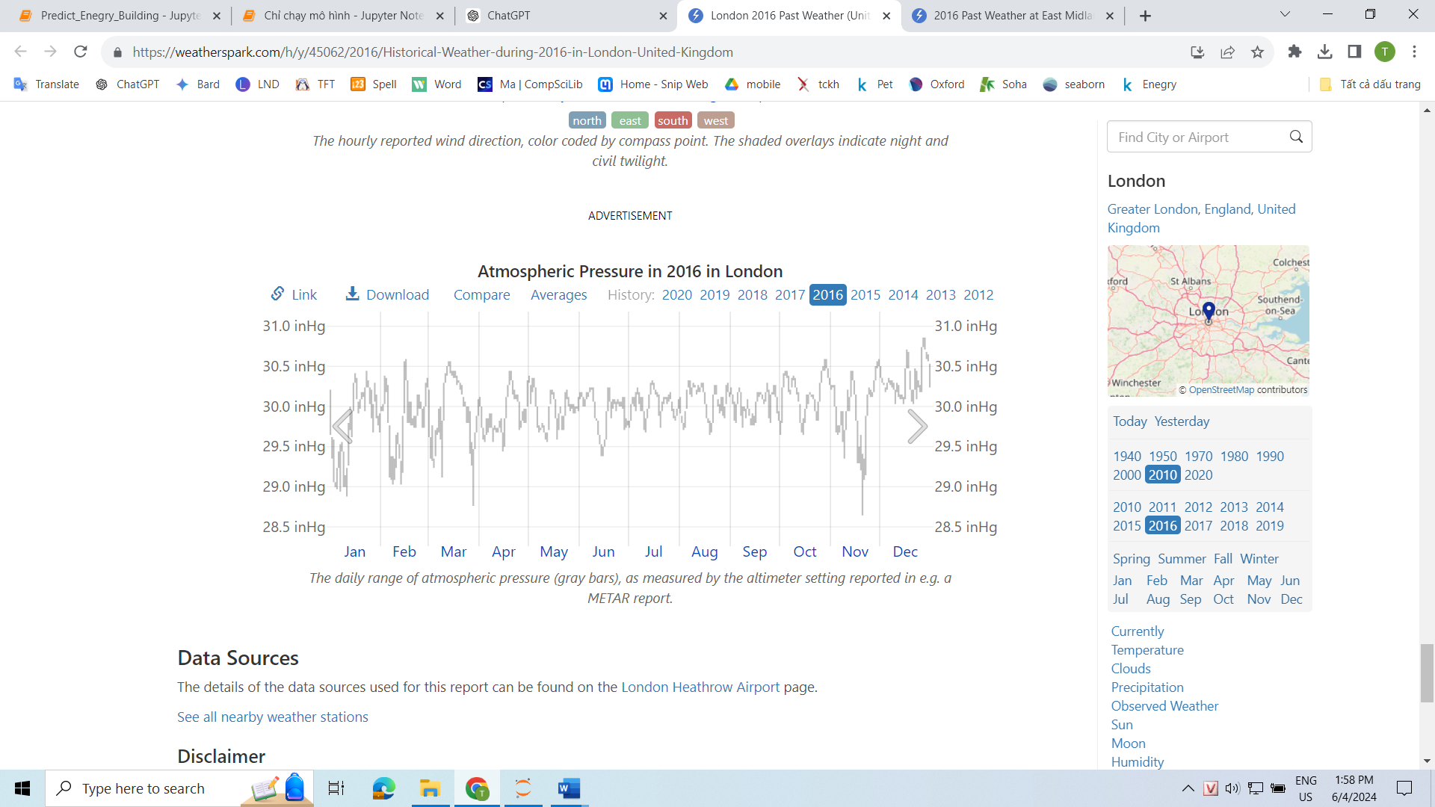



* These are two charts showing the air pressure in two cities, London and Loughborough. It can be observed that they are almost similar, with only some differences.
* Considering the geographical proximity of Loughborough to London, which is around 130 km apart with a slight elevation difference of 40 meters, we can use the sea_level_pressure data from site 1 and fill in the missing values at site 5.
* As for the NaN values in the cloud_coverage and precip_depth_1_hr attributes, we can replace them with -1, indicating that these are NaN data points.

## Train Data Preprocessing

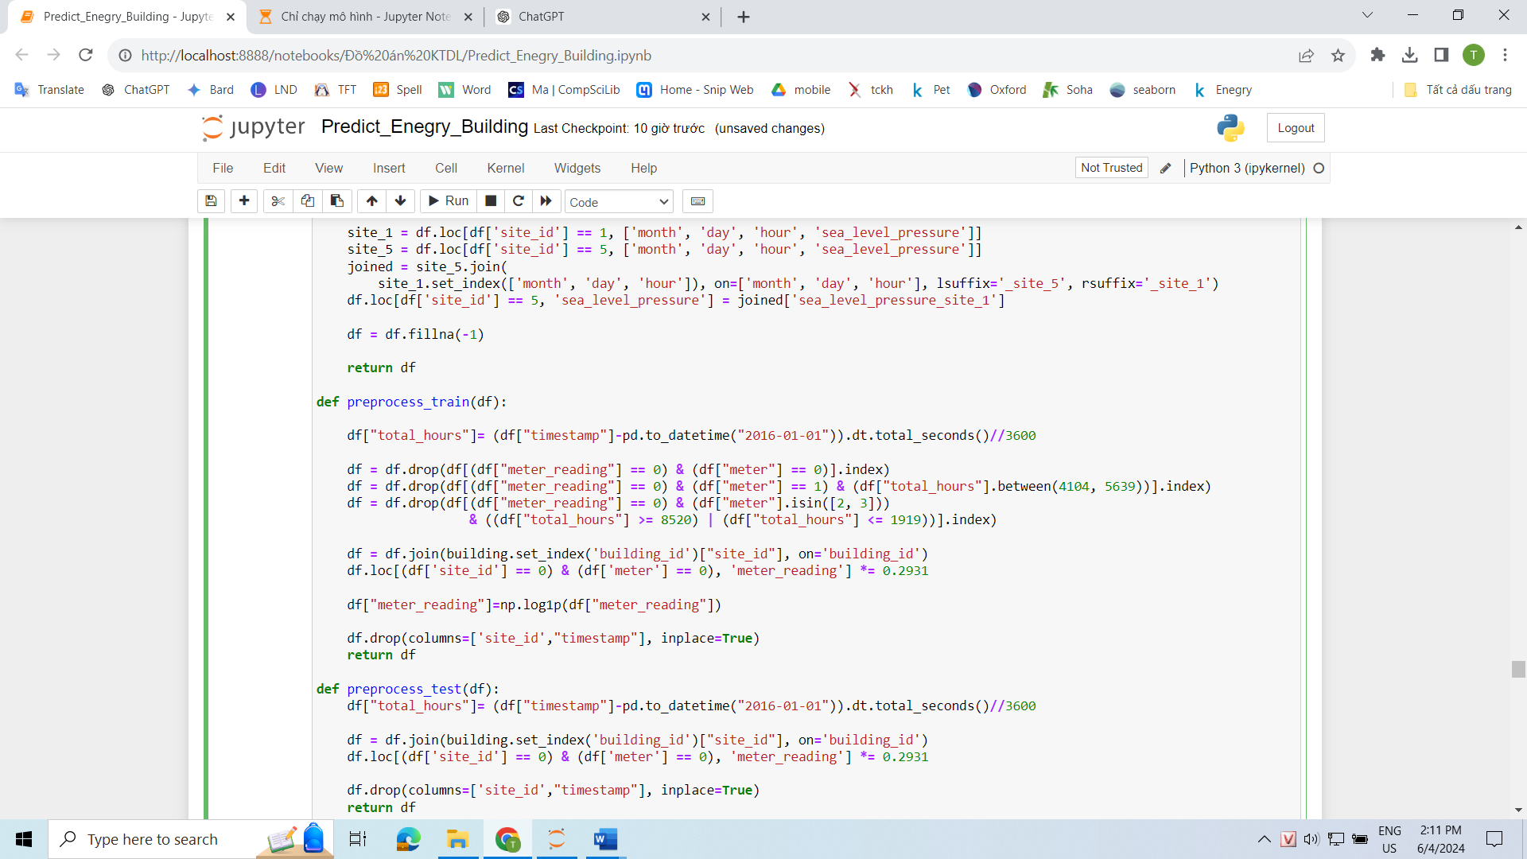

* We will remove the timestamp attribute and replace it with the total_hours attribute, using 2016-01-01 00:00:00 as the reference point. This change allows for easier joining with weather data that shares the same attribute. Additionally, since the timestamp attribute has a datetime64[ns] data type, which consumes a significant amount of memory, we will use the total_hours attribute with an int16 data type for efficiency.



* In the data description section, the dataset author mentioned that the meter_reading attribute for site_id = 0 and meter = 0 is incorrectly labeled with the unit kBTU instead of kWh, which is used for other rows.
* To address this issue, for the rows where site_id = 0 and meter = 0, we will multiply the meter_reading value by 0.2931 (kWh ≈ kBTU × 0.2931) to convert it to the correct unit of kWh.

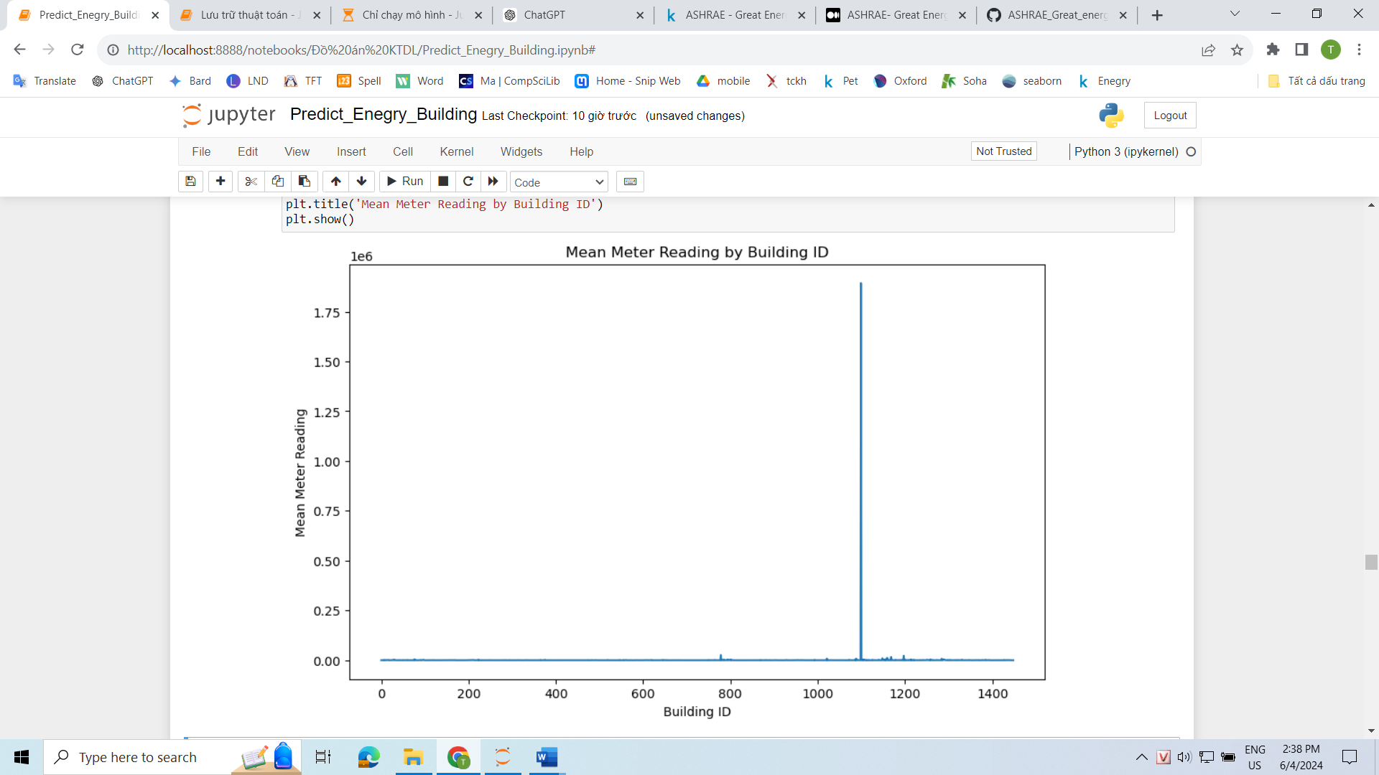

* This is a chart showing the average meter_reading for each building_id. We can observe that there is one building with a significantly higher mean meter_reading compared to all other buildings. This is undoubtedly an outlier in the data.

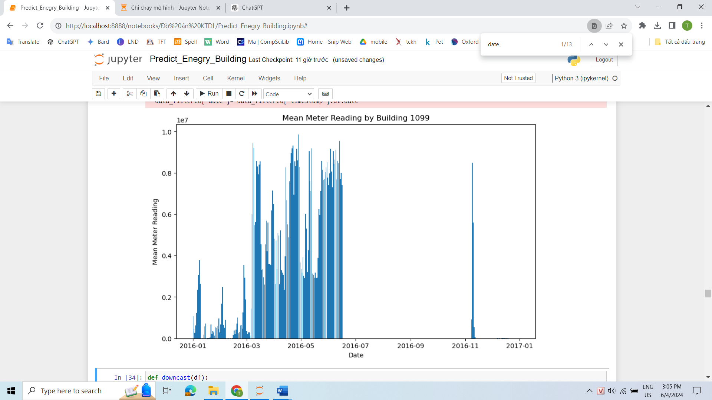

* It can be observed that during the spring season, the building has consumed a significant amount of energy, particularly in the rows where the meter value is 2, indicating water usage.
* We cannot simply discard this data because the meter_reading for this building occurs in multiple rows and spans over several months, rather than just a few days.

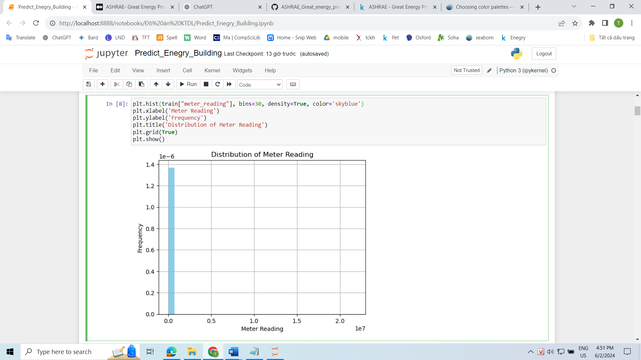

* It can be observed that the meter_reading values are heavily skewed towards one side, and the values themselves are quite large. This could potentially result in this attribute having a greater influence on the model compared to attributes with smaller values.
* To address these issues, we can transform the meter_reading column to a logarithmic scale using the formula log(x+1). We use log(x+1) because there are some rows with meter_reading values less than 1, which would lead to negative values when using log(x) transformation.

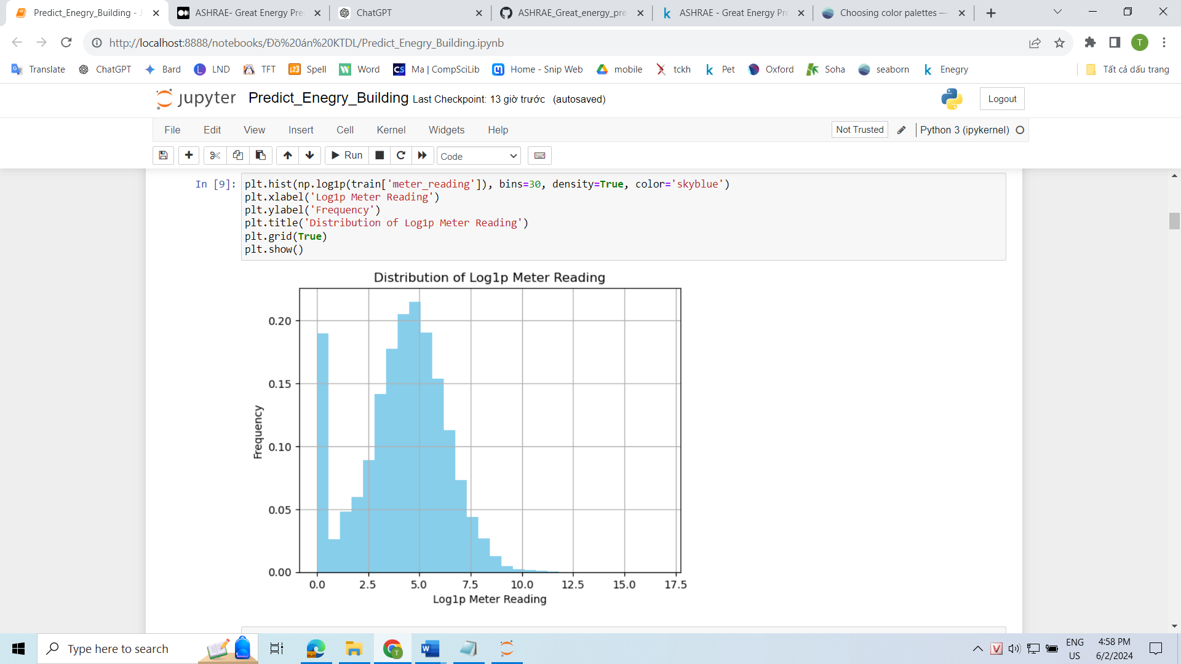

* The meter_reading values have shown improved variance and significantly reduced skewness after the logarithmic transformation. However, we can still observe a large number of meter_reading values equal to 0.

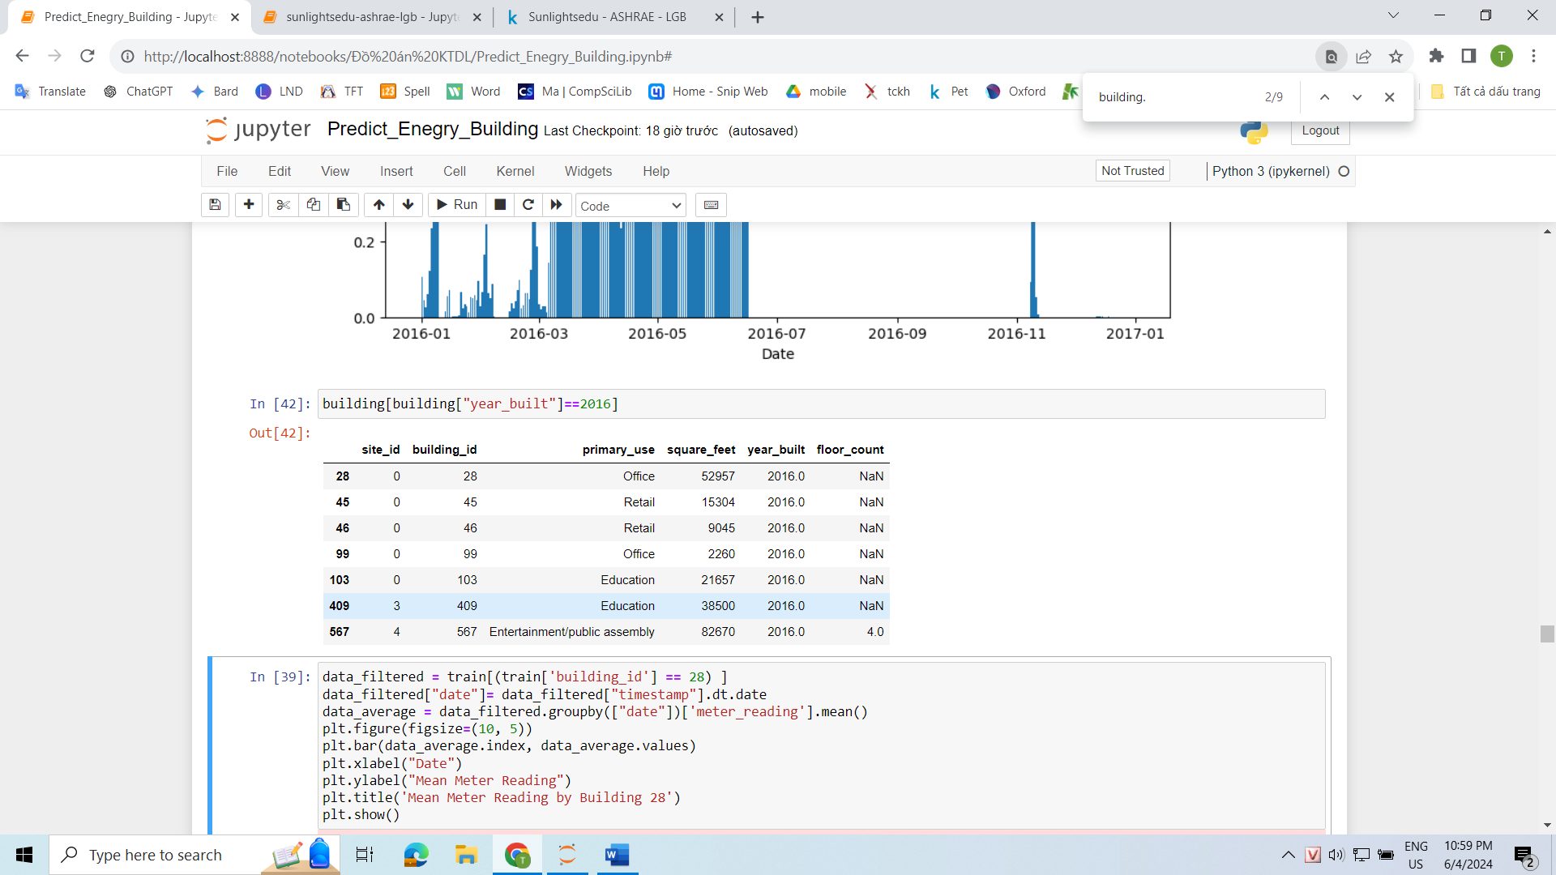

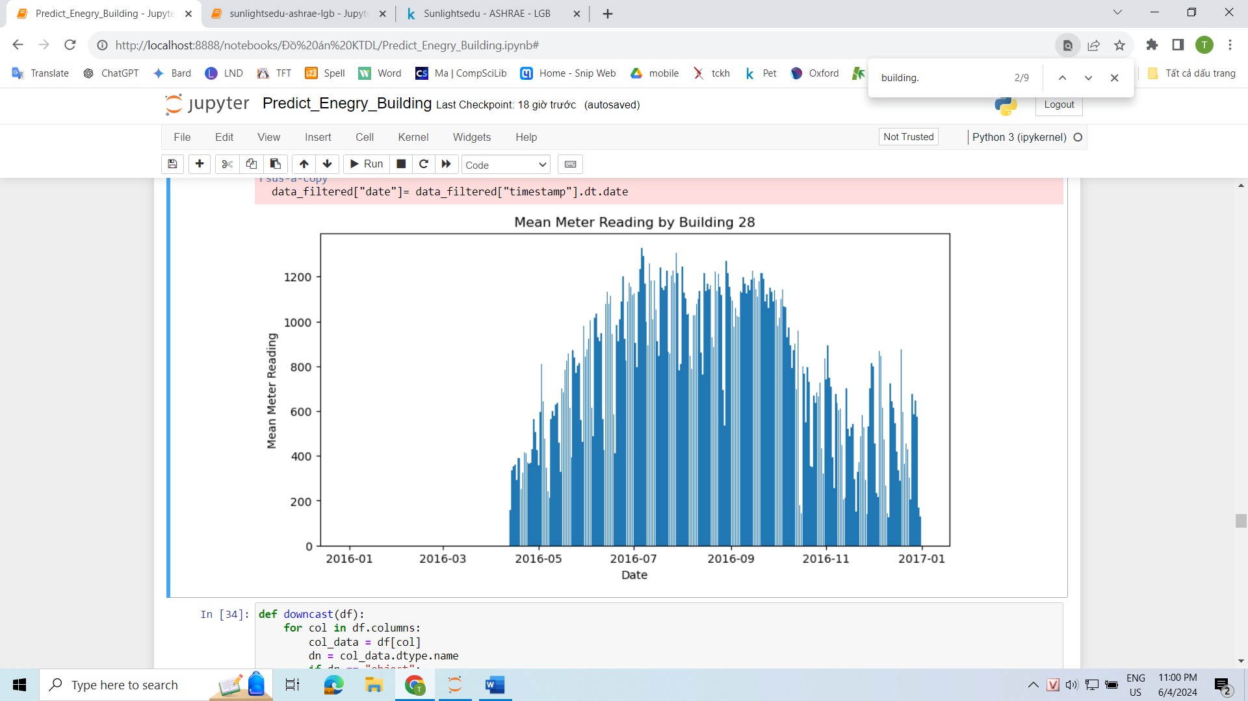

* Based on the image above, we can see that several buildings were constructed and opened in 2016, leading to many instances of meter_reading = 0. These values are meaningless and need to be removed.

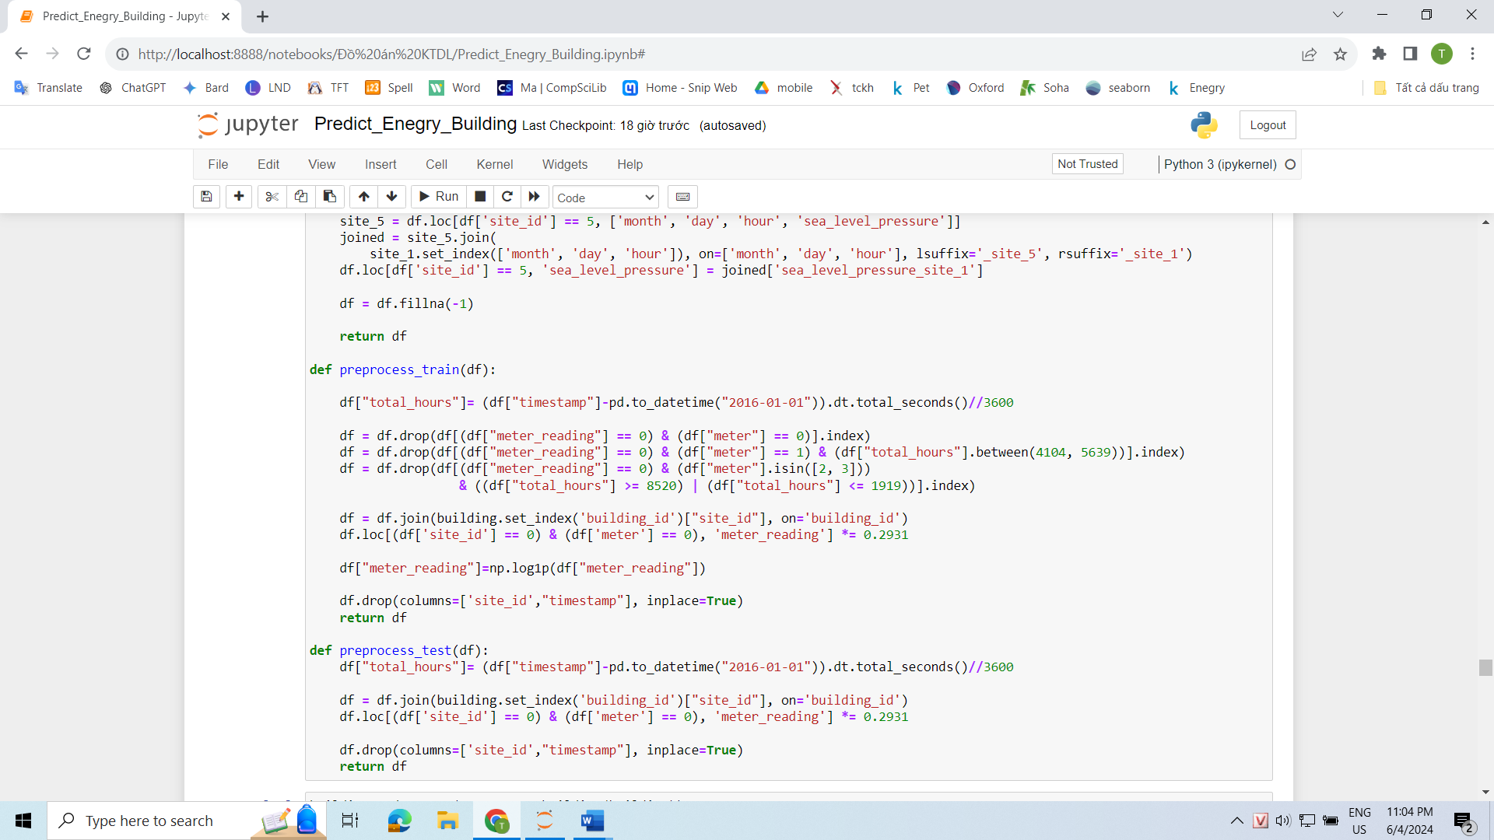

* For meters measuring electricity, energy consumption is unavoidable because these are buildings, and even if they are not in use, devices such as cameras and fire prevention systems still need electricity to operate. Therefore, having a meter reading of 0 for electricity meters is meaningless. The explanation for meter_reading = 0 could be that the meters are faulty and not recording data. Additionally, the area might have experienced a power outage or the building might not yet be in operation.
* For meters measuring chilled water, we will remove instances with meter_reading = 0 during the summer season (June 20 - September 22) because it is very hot in the summer, and not using chilled water is unusual.
* For meters measuring steam and hot water, we will remove instances with meter_reading = 0 during the summer season (December 21 - March 20) because it is very hot in the summer, and not using chilled water is unusual.

## Test Data Preprocessing

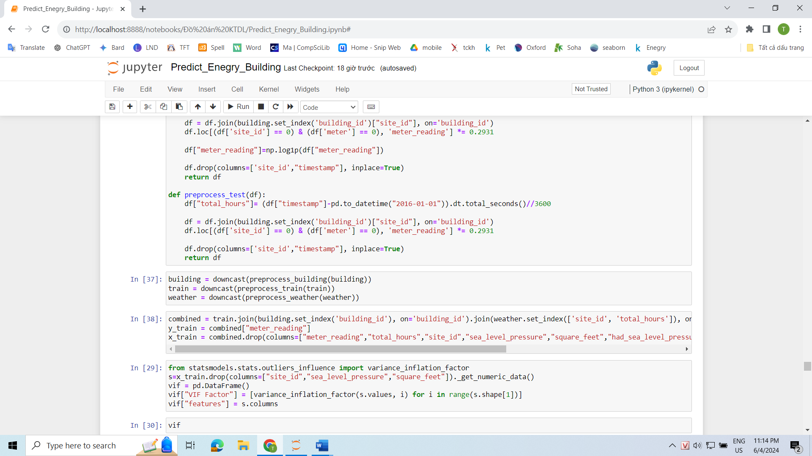

* To ensure the objectivity and accuracy of the data, we will perform only a few minor operations such as converting to total_hours to connect with the weather data and multiplying meter_reading by 0.2931 for site_id = 0 and meter = 0 because the author used the wrong unit.

## Combined Data Preprocessing

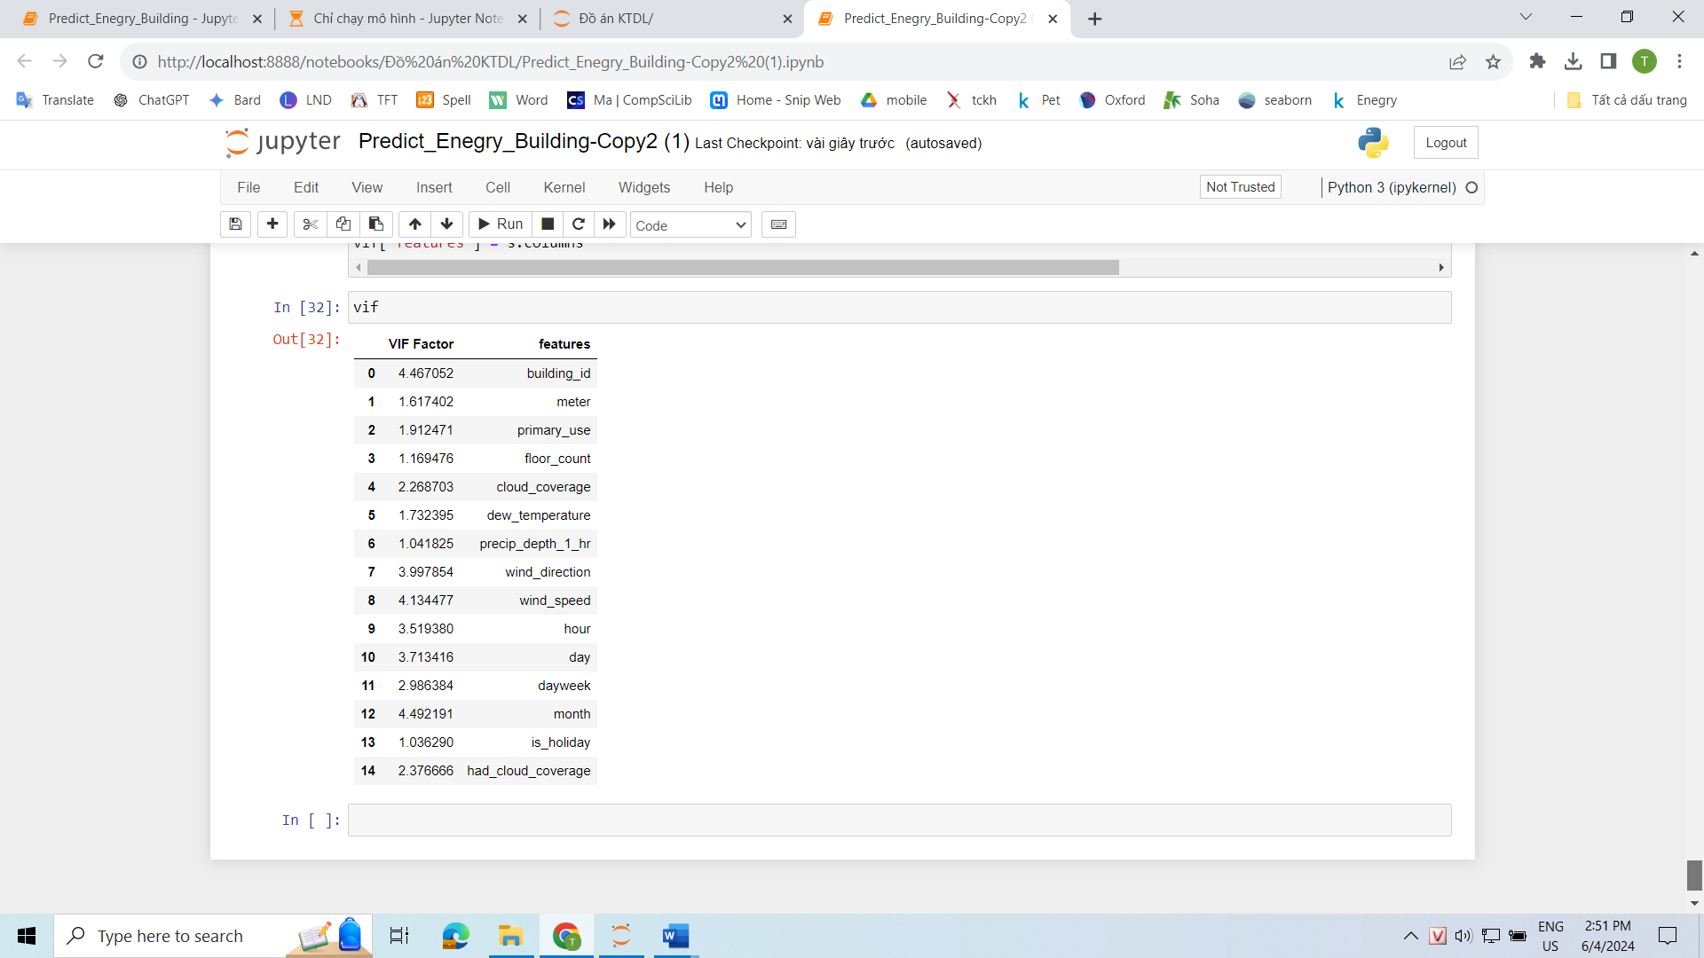

* After combining the 3 data frames, we will use the Variance Inflation Factor (VIF) technique. This technique will help us eliminate independent variables that are strongly correlated with each other.
* By gradually removing the attributes with the highest VIF until all VIFs are less than 5.
* The 7 attributes to be removed include site_id, sea_level_pressure, air_temperature, square_feet, had_sea_level_pressure, had_wind_direction, had_precip_depth_1_hr.

# DATA PREPROCESSING TECHNIQUES

## Linear Interpolation

Reason for choice: Since this is time series data, the rows are related to each other, especially in the weather data. We will use the neighboring rows of those with NaN values to help us fill them in.

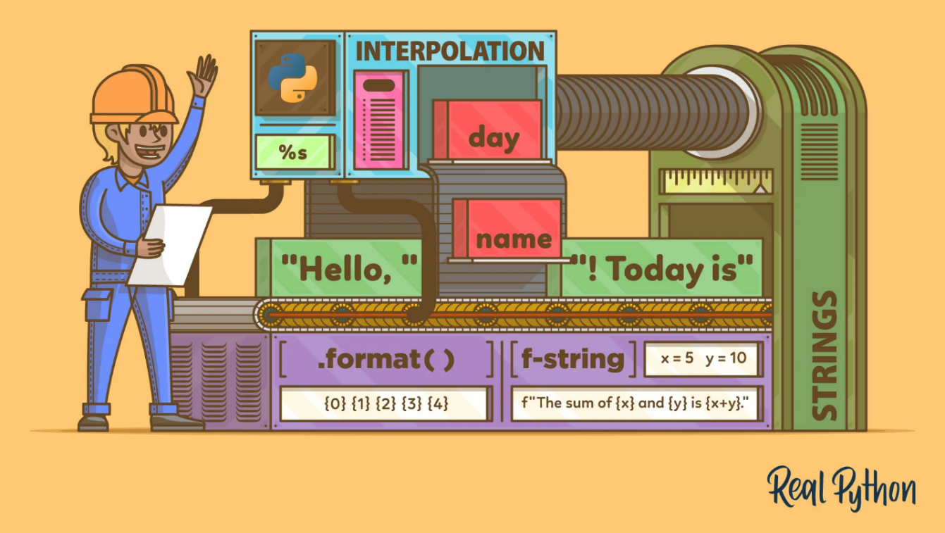

Definition: Linear interpolation is a straightforward technique employed to estimate the value of a function between two known data points or values. It provides a simple and effective way to make approximate predictions when you have a set of data points. The linear interpolation formula is particularly useful for curve fitting using linear polynomials.

Formula:

Where:

* x_1 and y_1 are the first coordinates
* x_2 and y_2 are the second coordinates
* x is the point to perform the interpolation
* y is the interpolated value

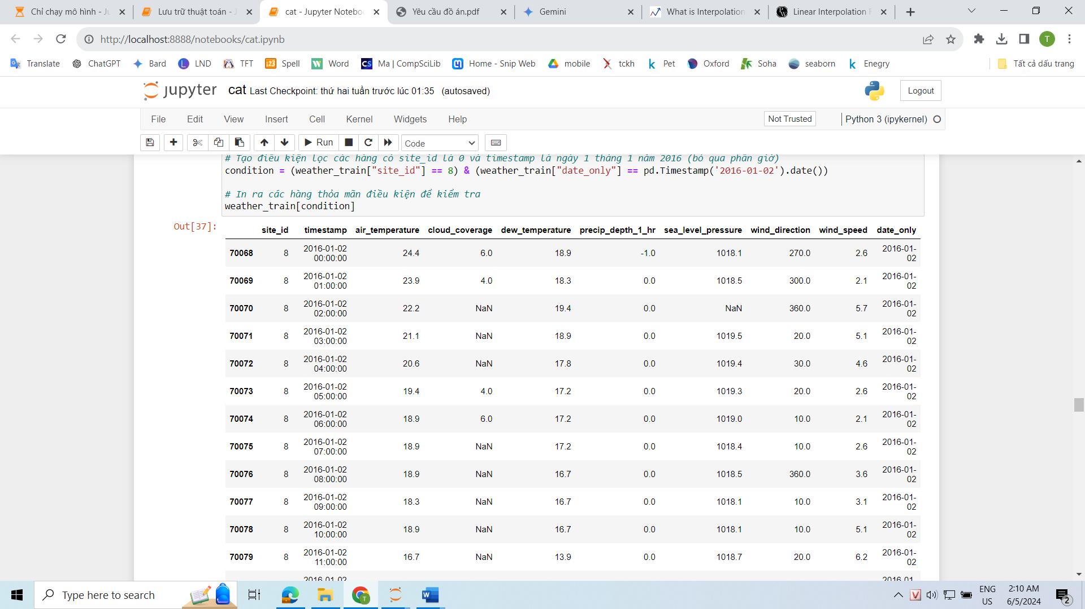

* For example, if the air_temperature column at row 70069 has a NaN value, linear interpolation will fill it in by

## Variance Inflation Factor

Reason for choice: To assess the impact of the independent variable on all other independent variables, avoiding unstable and unreliable coefficient estimates, which makes interpreting results and drawing meaningful conclusions from the model difficult.



Definition: A variance inflation factor (VIF) is a measure of the amount of multicollinearity in regression analysis. Multicollinearity exists when there is a correlation between multiple independent variables in a multiple regression model. This can adversely affect the regression results. Thus, the variance inflation factor can estimate how much the variance of a regression coefficient is inflated due to multicollinearity

Formula:

Where : : Unadjusted coefficient of determination for regressing the ith independent variable on the remaining ones

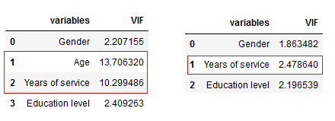

In general terms:

* VIF equal to 1 = variables are not correlated
* VIF between 1 and 5 = variables are moderately correlated
* VIF greater than 5 = variables are highly correlated

# APPLIED ALGORITHMS

## Decision tree

### Definition

The decision tree model is a type of supervised machine learning used for classification or making predictions based on answering a set of prior questions. It is used for both classification and regression tasks and works with both categorical and numerical data.

In a Decision Tree, there are two nodes, which are the Decision Node and Leaf Node. Decision nodes are used to make any decision and have multiple branches, whereas Leaf nodes are the output of those decisions and do not contain any further branches. A DT simply asks a question, and based on the answer (Yes/ No), it further split the tree into subtrees.

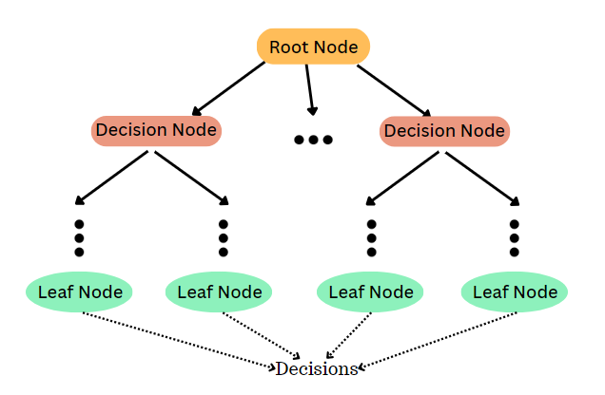

### Algorithm

**1. Start with the Big Picture:**

* The algorithm begins by considering the entire dataset as the root node of a tree.

**2. Split Strategically:**

* It identifies the most effective feature from the dataset for dividing the data into homogenous groups. This selection is based on a specific criterion like Gini impurity or information gain.
  + Gini impurity: Aims to minimize the mix of classes within each group.
  + Information gain: Aims to maximize the knowledge gained by splitting the data based on a particular feature.
* The chosen feature becomes the root node, and the data is separated into branches based on its potential values.

**3. Recursively Refine:**

* This splitting process is repeated for each data subset (branch), considering the remaining features. This recursive approach continues until the entire tree is built.
* At each node, the algorithm evaluates various splitting criteria to determine the optimal feature for further division.

**4. Stopping at the Right Point:**

* The recursive construction halts when a predefined stopping criterion is met. Common criteria include:
  + Maximum tree depth: Limits the depth to avoid overfitting.
  + Minimum instances per leaf: Ensures a minimum number of data points in each leaf node to prevent overfitting.
  + Pure leaf nodes: Creates leaf nodes when all data points within a node belong to the same class (classification) or have similar values (regression).

**5. Making Predictions:**

* Once the tree is constructed, predictions for new data points are made by traversing the tree from the root to a leaf node.
* At each node, the data point is compared to the feature value and directed down the appropriate branch based on that value.
* This process continues until a leaf node is reached. The class label (classification) or predicted value (regression) associated with that leaf node becomes the prediction for the data point.

### Reason for choice

* **Ability to model complex relationships**: Decision Trees can model nonlinear relationships between variables in a flexible manner.
* **No pre-assumptions required**: Decision Trees do not require prior assumptions about the relationships between variables, making them well-suited for various types of complex data.
* **Interaction detection capability**: Decision Trees can detect interactions between variables, enabling the model to learn hidden nonlinear relationships.

## LightGBM

### Definition

LightGBM is an ensemble learning framework, specifically a gradient boosting method, which constructs a strong learner by sequentially adding weak learners in a gradient descent manner. It optimizes memory usage and training time with techniques like Gradient-based One-Side Sampling (GOSS)

### Algorithm

**1. Leaf-wise Tree Growth:**

* LightGBM builds decision trees in a leaf-wise manner. This means it focuses on splitting a single leaf node at a time, based on the potential gain it offers. While this approach offers efficiency, it can lead to overfitting, especially with limited data.
* To mitigate overfitting, LightGBM allows you to limit the maximum depth of the trees.

**2. Histogram-based Splitting:**

* LightGBM employs a histogram-based approach for splitting data. Instead of utilizing each data point individually, it creates bins (buckets) using a histogram of the data's distribution.
* The algorithm iterates over these bins, calculates the gain, and decides on the optimal split point. This method is particularly efficient for sparse datasets.

**3. Exclusive Feature Bundling:**

* To reduce dimensionality and enhance efficiency, LightGBM incorporates a technique called exclusive feature bundling. This involves combining features that are mutually exclusive (cannot occur together) into a single feature.

**4. Gradient-based One-Side Sampling (GOSS):**

* LightGBM utilizes GOSS for data sampling during the training process. This technique assigns higher weights to data points with larger gradients (errors).
* Essentially, it prioritizes instances that haven't been well-learned by the model. While some data points with smaller gradients are retained for accuracy, others are randomly removed.
* Compared to random sampling with the same sampling rate, GOSS generally leads to better results

### Reason for choice

* **Fast training speed**: Much faster than other models.
* **Efficient memory usage**: Saves computational resources.
* **Handling large datasets**: Highly effective with massive datasets.

## XGBoost

### Definition

XGBoost, which stands for Extreme Gradient Boosting, is a scalable, distributed gradient-boosted decision tree (GBDT) machine learning library. It provides parallel tree boosting and is the leading machine learning library for regression, classification, and ranking problems.

### Algorithm

**Step 1: Initialization**

Begin with an initial weak model, typically a simple decision tree.

Train this model on the data and calculate the prediction errors (the differences between the model's predictions and the actual values)

**Step 2: Add a New Weak Model**

Create a new decision tree with the objective of minimizing the prediction errors of the current model.

Apply this new model to the data and compute new predictions.

Update the prediction errors by taking the difference between the new predictions and the actual values.

**Step 3: Repeat**

Repeat step 2 until a certain stopping criterion is met, such as reaching the maximum number of trees or achieving the desired accuracy.

At each iteration, a new weak model is added to improve the overall performance of the model.

**Step 4: Combine Predictions**

Combine the predictions from all the weak models in the ensemble to generate the final prediction for each data point.

There are various methods for combining predictions, such as averaging or majority voting.

### Reason for choice

* High accuracy: XGBoost often achieves higher accuracy compared to other machine learning algorithms.
* Scalability: XGBoost can efficiently handle large datasets.
* Overfitting prevention: XGBoost uses techniques like L1 and L2 regularization to prevent the model from overfitting to the training data.

## Stacking

### Definition

Stacking ,short for Stacked Generalization, is a machine learning strategy that combines the predictions of numerous base models, also known as first-level models or base learners, to obtain a final prediction

### Algorithm

**1. Split the Data:**

* Divide the initial dataset into two parts: training and validation sets.

**2. Train Level-0 Models (Base Models):**

* Train a set of diverse machine learning models (e.g., decision trees, random forests) on the training data. These models are called base models.

**3. Make Predictions on Validation Set:**

* Use the trained base models to generate predictions for the validation set. These predictions represent the output from each base model for each data point in the validation set.

**4. Prepare Data for Meta-Model:**

* Combine the original labels (target variable) from the validation set with the predictions made by all the base models for the same data points. This creates new input-output pairs for the meta-model.

**5. Train the Meta-Model (Level-1 Model):**

* Train a new model (the meta-model) using the combined data from step 4. The meta-model learns to leverage the strengths of the various base models to improve overall prediction accuracy.

**6. Make Final Predictions:**

* Once trained, use the meta-model to make predictions for new, unseen data points. The meta-model will consider the combined insights from the base models to generate more accurate final predictions.

### Reason for choice

* Enhanced Accuracy: Stacking combines predictions from multiple models, reducing errors and improving overall accuracy.
* Reduced Overfitting: Stacking mitigates overfitting by combining diverse models, preventing excessive focus on training data details.
* Improved Stability: Stacking enhances stability by averaging predictions, reducing random fluctuations in performance.

# ACHIEVED RESULTS

## Measurement

### Mean Absolute Error (MAE)

Definition: MAE measures the average of the absolute differences between the predicted and actual values.

Formula:

Where:

* n is the number of samples in the dataset.
* is the actual value of the i-th sample.
* is the predicted value of the i-th sample.

Significance: MAE is a straightforward metric that represents the average magnitude of the prediction errors. It is easy to interpret and understand, indicating the average distance between the predicted and actual values.

### Root Mean Squared Error (RMSE)

Definition: RMSE measures the average of the squared differences between the predicted and actual values.

Formula:

Where:

* n is the number of samples in the dataset.
* is the actual value of the i-th sample.
* is the predicted value of the i-th sample.

Significance: RMSE is similar to MAE but squares the errors, giving more weight to larger errors. It is particularly useful for continuous target variables as it penalizes large errors more heavily.

### Root Mean Squared Logarithmic Error (RMSLE)

Definition: RMSLE measures the average of the squared logarithmic differences between the predicted and actual values.

Formula:

Where:

* n is the number of samples in the dataset.
* is the actual value of the i-th sample.
* is the predicted value of the i-th sample.

Significance: RMSLE is a variant of RMSE specifically designed for dealing with non-negative target variables, particularly those with a wide range of values. It transforms the values into logarithmic scale before calculating the squared errors, giving more weight to errors in smaller magnitudes.

### R-squared (Coefficient of Determination)

Definition: R-squared measures the proportion of the variance in the target variable that is predictable by the model.

Formula:

Where:

* n is the number of samples in the dataset.
* is the actual value of the i-th sample.
* is the predicted value of the i-th sample.
* is the mean of the actual values.

Significance: It indicates how well the model can explain the variance in the target variable based on the changes in the input variables. The closer the R-squared value is to 1, the better the model can explain the variance of the target variable, meaning the model can predict the target variable well based on the input variables. Conversely, the closer the R-squared value is to 0, the poorer the model's explanatory power, indicating that the model cannot predict the target variable well.

## Reason for choice

* MAE: It provides the average of the absolute errors between predicted values and actual values, with the principle that both small and large errors are equally important.
* RMSE: Similar to MAE but with squared errors, placing more emphasis on larger errors. It is particularly useful for continuous target variables as it penalizes larger errors more heavily.
* RMSLE: When the target variable "meter_reading" ranges from 0 to 20 million, RMSLE is preferable as it is suitable for variables with a wide range of values while placing more emphasis on smaller errors.
* R-squared (R2): It indicates how well the model can explain the variance in the target variable based on changes in the input variables. The closer the R2 value is to 1, the better the model can explain the variance of the target variable, meaning the model can predict the target variable well based on the input variables. Conversely, the closer the R2 value is to 0, the poorer the model's explanatory power, indicating that the model cannot predict the target variable well.

## Result

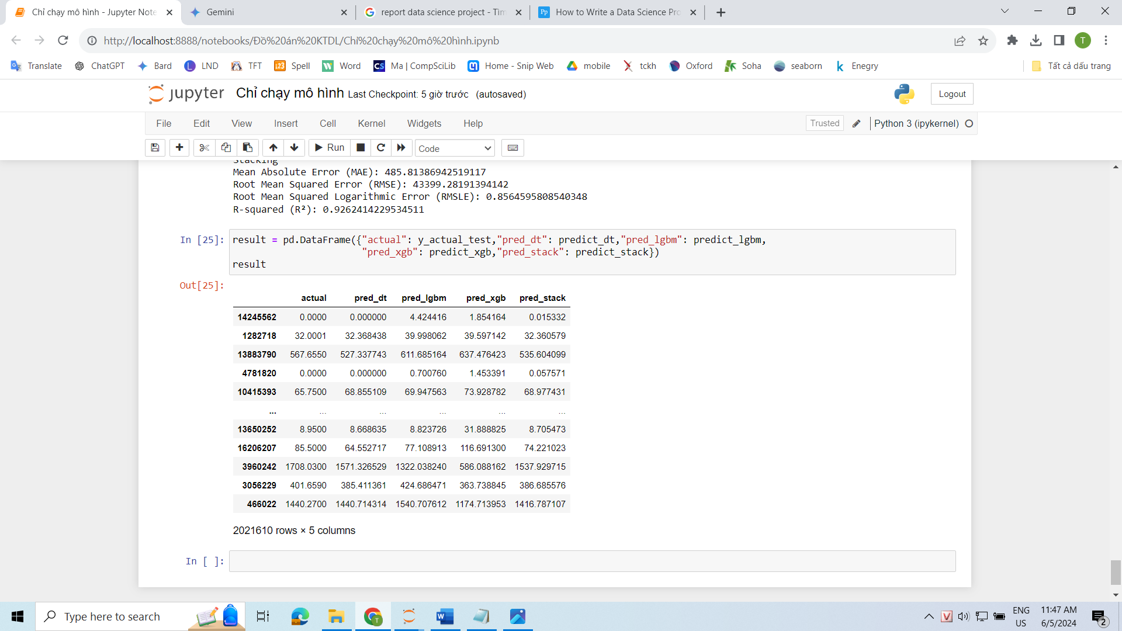

|  |  |  |  |  |
| --- | --- | --- | --- | --- |
| **Machine Learning Algorithm** | **MAE** | **RMSE** | **RMSLE** | **R2** |
| **Decision Tree** | 315.0408 | 33768.42 | 0.865167 | 0.955345 |
| **LightGBM** | 794.1283 | 74092.14 | 0.889023 | 0.785023 |
| **XGBoost** | 950.7654 | 79531.55 | 1.056645 | 0.752299 |
| **Stacking** | 485.8139 | 43399.28 | 0.856459 | 0.926241 |

## 

## Comparison and Evaluation

* Time:
* Decision Tree has the fastest speed, taking only 15 minutes for 12 runs (3 folds x 4 metrics)
* LightGBM is the second fastest, taking 30 minutes, followed by XGBoost at 40 minutes.
* Since Stacking is an ensemble of all three base learners, its training time is unsurprisingly the longest, combining the training times of the individual models.
* However, if the three base learners are trained beforehand, Stacking only needs to run the meta-learner, Linear Regression, which takes about 5 minutes for 12 runs.
* Accuracy:
* Decision Tree outperforms the other models with the best MAE, RMSE, and R2 scores. This indicates its ability to handle non-linear data and makes it the most suitable model for predicting building energy consumption.
* XGBoost, on the other hand, has the worst results among the four models with the lowest MAE, RMSE, RMSLE, and R2 scores. However, objectively speaking, its performance is not too bad, as it can explain 75.2299% of the data variation.
* LightGBM performs decently compared to the other four models, with an RMSLE of 0.889, indicating good prediction for small values. However, its RMSE is 74092, suggesting that its prediction is only average for large values.
* Stacking surprisingly has lower performance metrics than Decision Tree but the highest RMSLE. This shows that the model performs well when predicting small values.

# CONCLUSION

## Advantages

* We have developed effective machine learning models to accurately predict the energy consumption of buildings, with the Decision Tree model being the most prominent.
* Additionally, we have utilized various advanced techniques such as Variance Inflation Factor and Linear Interpolation, which proved to be very effective.
* During the project, by processing and visualizing the data, we gained many useful insights, such as explaining why certain independent variables are important and how they significantly impact the prediction results.

## Disadvantages

* The lack of consistent data makes analysis and prediction difficult and time-consuming to correctly realign.
* The dataset comprises buildings from abroad; having datasets of buildings and energy consumption levels specific to Vietnam would be more practical and beneficial to society

## Development direction

* Utilizing deep learning models for the problem as they can learn complex nonlinear relationships while being able to handle various types of data.
* Combining with time-series models such as ARIMA. Due to the lack of sufficient data, ARIMA model training has not been conducted yet. The dataset only contains data from the year 2016, which means 366 days. If we split the data into an 80/20 ratio, approximately the first 9 months are for training and the remaining the months(10,11,12) are for testing. Using data from spring, summer, and fall to predict winter may render the training data less meaningful.
* Integrating with energy management systems. This will provide building owners with a clearer understanding of energy consumption, enabling them to make more informed decisions. For example, if a building consumes a lot of energy and emits a significant amount of CO2, the owner can implement measures such as renovations to reduce energy consumption

# ORTHER

## The task assignment table of team members

|  |  |  |  |  |  |  |
| --- | --- | --- | --- | --- | --- | --- |
| **Order** | **Student ID** | **Full Name** | **Description of Assigned Tasks** | **Total Assigned Work (% of assigned tasks)** | **Ability to Complete Assigned Tasks (% completion)** | **Role** |
| 1 | 21521982 | Thái Ngọc Dũng | Topic selection  Data preprocessing  Applying algorithms to train models  Evaluating results from models | 50% | 100% | Leader |
| 2 | 21522420 | Trần Hoàng Nhật | Topic selection  Finding datasets  Descriptive data analysis  Data visualization  Writing report | 50% | 100% | Member |

## References

[https://en.wikipedia.org/wiki/Okta](https://uithcm-my.sharepoint.com/:w:/g/personal/21522653_ms_uit_edu_vn/EWazU12F-k5MmP9WpsbbLyMBGLBsCp2SsDx4jBXfSybP5A)

[https://www.pinterest.co.uk/pin/95068242119755050/](https://uithcm-my.sharepoint.com/:w:/g/personal/21522653_ms_uit_edu_vn/EWazU12F-k5MmP9WpsbbLyMBGLBsCp2SsDx4jBXfSybP5A)

[https://www.ashrae.org/file%20library/communities/regions/ashrae_2021.pdf](https://uithcm-my.sharepoint.com/:w:/g/personal/21522653_ms_uit_edu_vn/EWazU12F-k5MmP9WpsbbLyMBGLBsCp2SsDx4jBXfSybP5A)

[https://weatherspark.com/compare/y/32022~36848~45062~33845~41795~48821/Comparison-of-the-Average-Weather-in-Lisbon-Madrid-London-Dublin-Loughborough-and-Lagos](https://uithcm-my.sharepoint.com/:w:/g/personal/21522653_ms_uit_edu_vn/EWazU12F-k5MmP9WpsbbLyMBGLBsCp2SsDx4jBXfSybP5A)

[https://realpython.com/python-string-interpolation/](https://uithcm-my.sharepoint.com/:w:/g/personal/21522653_ms_uit_edu_vn/EWazU12F-k5MmP9WpsbbLyMBGLBsCp2SsDx4jBXfSybP5A)

[https://pypi.org/project/holidays/](https://uithcm-my.sharepoint.com/:w:/g/personal/21522653_ms_uit_edu_vn/EWazU12F-k5MmP9WpsbbLyMBGLBsCp2SsDx4jBXfSybP5A)

[https://weatherspark.com/h/y/45062/2016/Historical-Weather-during-2016-in-London-United-Kingdom](https://uithcm-my.sharepoint.com/:w:/g/personal/21522653_ms_uit_edu_vn/EWazU12F-k5MmP9WpsbbLyMBGLBsCp2SsDx4jBXfSybP5A)

[https://weatherspark.com/h/y/147821/2016/Historical-Weather-during-2016-at-East-Midlands-Airport-United-Kingdom#Figures-Summary](https://uithcm-my.sharepoint.com/:w:/g/personal/21522653_ms_uit_edu_vn/EWazU12F-k5MmP9WpsbbLyMBGLBsCp2SsDx4jBXfSybP5A)

[https://www.analyticsvidhya.com/blog/2020/03/what-is-multicollinearity/](https://uithcm-my.sharepoint.com/:w:/g/personal/21522653_ms_uit_edu_vn/EWazU12F-k5MmP9WpsbbLyMBGLBsCp2SsDx4jBXfSybP5A)

[https://www.analyticsvidhya.com/blog/2021/06/power-of-interpolation-in-python-to-fill-missing-values/](https://uithcm-my.sharepoint.com/:w:/g/personal/21522653_ms_uit_edu_vn/EWazU12F-k5MmP9WpsbbLyMBGLBsCp2SsDx4jBXfSybP5A)

[https://medium.com/@nidhigh/decision-trees-a-powerful-tool-in-machine-learning-dd0724dad4b6](https://uithcm-my.sharepoint.com/:w:/g/personal/21522653_ms_uit_edu_vn/EWazU12F-k5MmP9WpsbbLyMBGLBsCp2SsDx4jBXfSybP5A)

[https://www.geeksforgeeks.org/lightgbm-light-gradient-boosting-machine/](https://uithcm-my.sharepoint.com/:w:/g/personal/21522653_ms_uit_edu_vn/EWazU12F-k5MmP9WpsbbLyMBGLBsCp2SsDx4jBXfSybP5A)

[https://medium.com/@prathameshsonawane/xgboost-how-does-this-work-e1cae7c5b6cb](https://uithcm-my.sharepoint.com/:w:/g/personal/21522653_ms_uit_edu_vn/EWazU12F-k5MmP9WpsbbLyMBGLBsCp2SsDx4jBXfSybP5A)

[https://medium.com/@brijesh_soni/stacking-to-improve-model-performance-a-comprehensive-guide-on-ensemble-learning-in-python-9ed53c93ce28#:~:text=Stacking%20is%20a%20strong%20ensemble,stacked%20ensembles%20or%20stacked%20generalization.](https://uithcm-my.sharepoint.com/:w:/g/personal/21522653_ms_uit_edu_vn/EWazU12F-k5MmP9WpsbbLyMBGLBsCp2SsDx4jBXfSybP5A)